Task 1: Configure Classic Load Balancer
Objective
Classic Load Balancer ni create chesi incoming user traffic ni multiple EC2 instances madhya distribute cheyyadam.
Benefits:
✅ High Availability
✅ Fault Tolerance
✅ Load Distribution

Architecture
User
|
|
Classic Load Balancer
|
---------------------
| |
WebServer-1 WebServer-2
(us-east-2a) (us-east-2b)

Step 1: Created Two EC2 Instances
Manam rendu EC2 instances create chesam.
WebServer-1
Region : Ohio
AZ : us-east-2a
WebServer-2
Region : Ohio
AZ : us-east-2b

Why Two Availability Zones?
Suppose:
us-east-2a fails
WebServer-1 down aipothundi.
But:
WebServer-2
still available untundi.
Application down avvadu.
Dini High Availability antaru.

Step 2: Installed Apache Web Server
User Data script use chesam.
WebServer-1
This is Server 1
WebServer-2
This is Server 2
Purpose:
Traffic ye server ki velthundo identify cheyyadaniki.

Step 3: Configured Security Groups
Added:
SSH
Port 22
Purpose:
Server ki connect avvadam.

HTTP
Port 80
Purpose:
Browser nundi webpage access cheyyadam.

Step 4: Verified EC2 Instances
Browser lo open chesam.
WebServer-1
http://Public-IP
Output:
This is Server 1

WebServer-2
http://Public-IP
Output:
This is Server 2
Meaning:
Apache server successfully running.

Step 5: Created Classic Load Balancer
Created:
my-classic-lb
Type:
Internet Facing

Why Internet Facing?
Because:
Users from Internet
direct ga access cheyyali.

Step 6: Selected Multiple Availability Zones
Selected:
us-east-2a
us-east-2b
Why?
CLB multiple AZs lo deploy avvadaniki.
Benefits:
High Availability
Fault Tolerance

Step 7: Configured Listener
Configured:
HTTP : 80
Meaning:
User
|
HTTP Request
|
CLB
|
EC2
Traffic port 80 lo receive chesi EC2 ki forward chestundi.

Step 8: Configured Health Check
Configured:
Protocol : HTTP
Port : 80
Path : /

Why Health Check?
CLB continuously check chestundi:
Server healthy ga unda?
Example:
WebServer-1 = Healthy
WebServer-2 = Healthy
Traffic rendu servers ki distribute avuthundi.

Suppose:
WebServer-2 crashes
Health check fail avuthundi.
CLB immediately:
Stop sending traffic
to WebServer-2.
Traffic motham:
WebServer-1
ki velthundi.

Step 9: Registered EC2 Instances
Added:
WebServer-1
WebServer-2
to Load Balancer.
Meaning:
CLB backend servers ga ee instances ni use chestundi.

Step 10: Verified DNS Endpoint
AWS automatically DNS create chesindi.
Example:
my-classic-lb-xxxx.us-east-2.elb.amazonaws.com
User browser lo open chesthe:
DNS
↓
CLB
↓
EC2
request route avuthundi.

Load Balancing Verification
Browser lo DNS open chesi refresh chesthe:
This is Server 1
Refresh:
This is Server 2
Refresh:
This is Server 1
Idi traffic distribution jarugutundani prove chestundi.

Real-Time Flow
User opens website
|
|
V
Classic Load Balancer
|
---------------------
| |
V V
WebServer-1 WebServer-2
CLB:
- Request receive chestundi.
- Healthy instances identify chestundi.
- Traffic ni distribute chestundi.
- Failed instances ki traffic pampadu.

Interview Answer (2 Lines)
"I created two Apache web servers in different Availability Zones and attached them to a Classic Load Balancer. The load balancer distributes incoming traffic across healthy EC2 instances and improves high availability and fault tolerance."
Telugu Simple Version
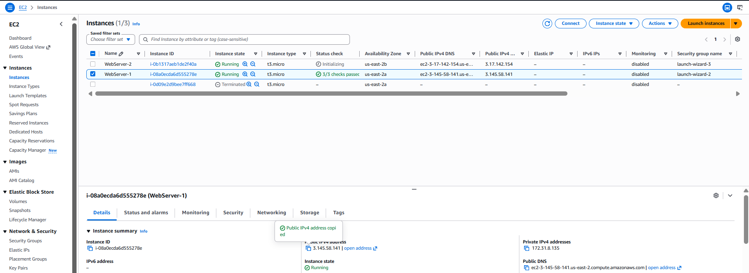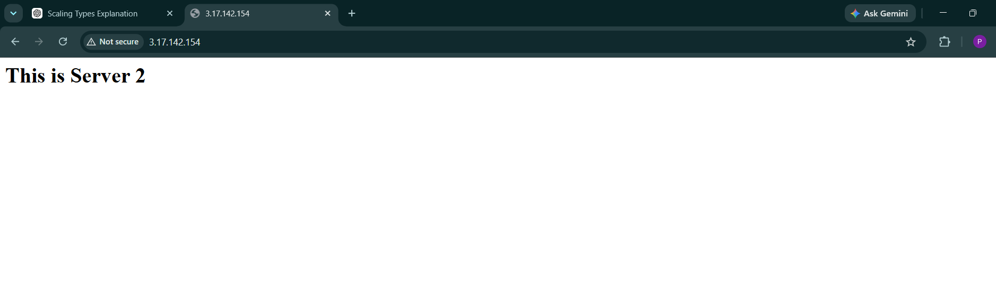
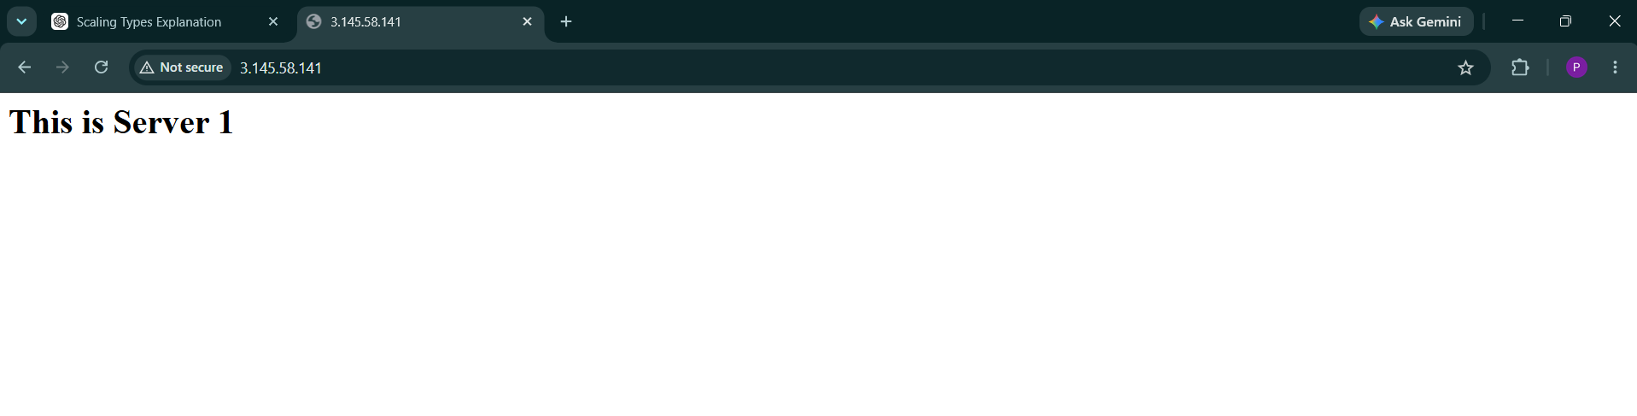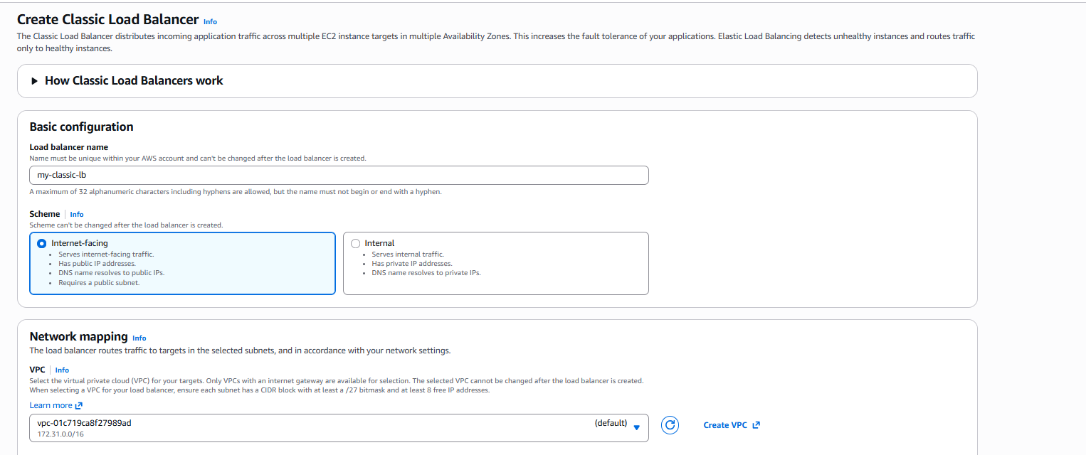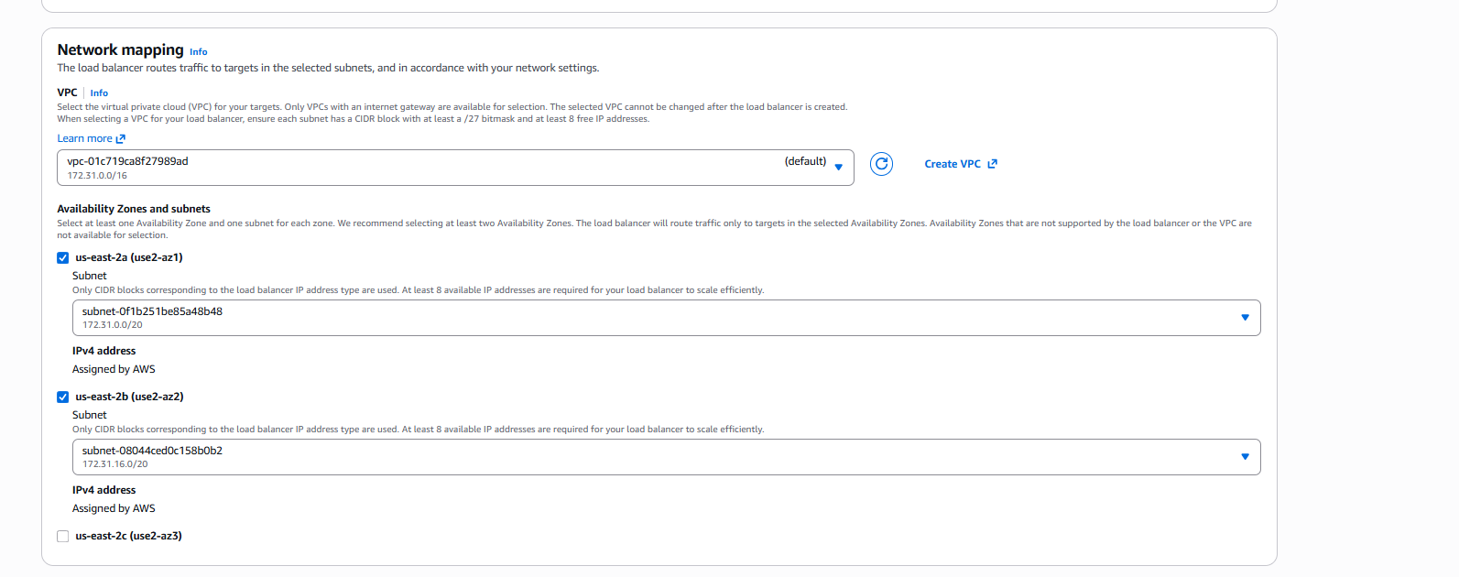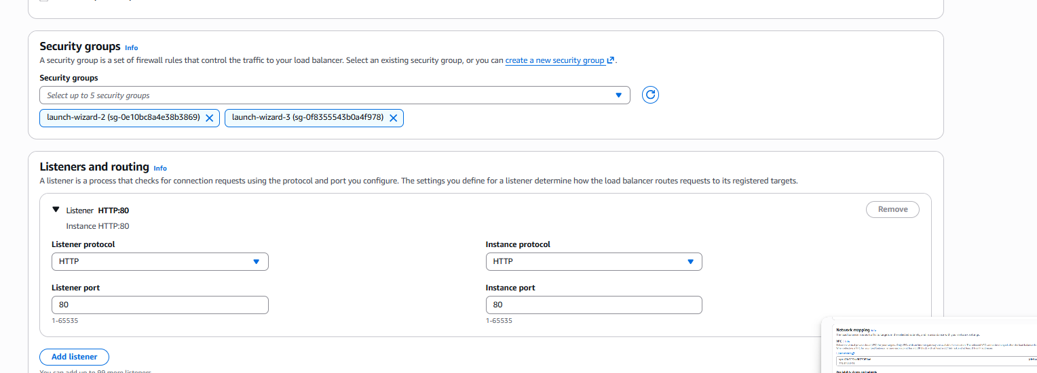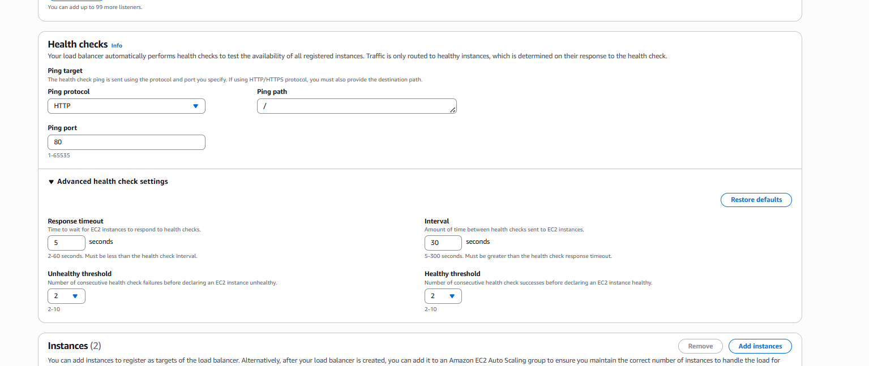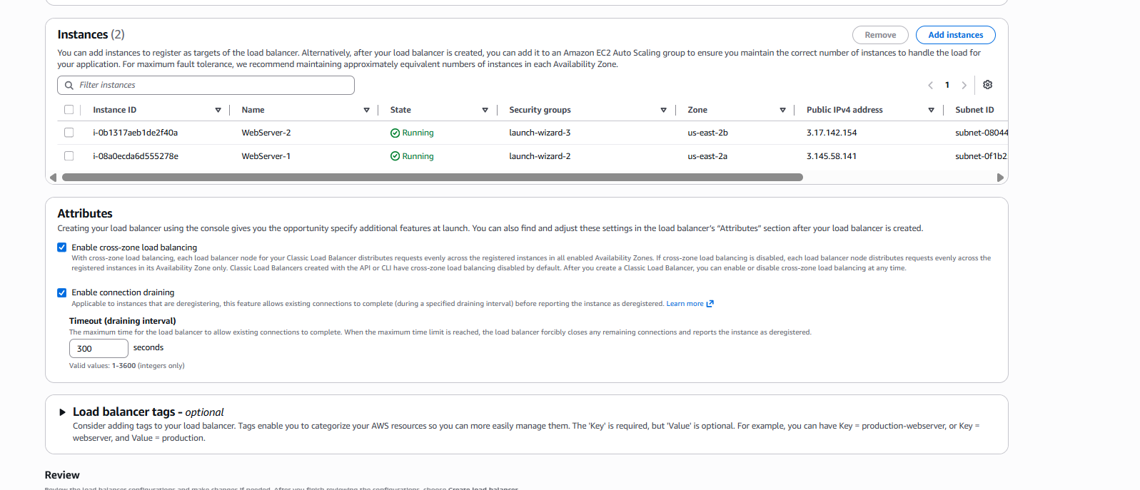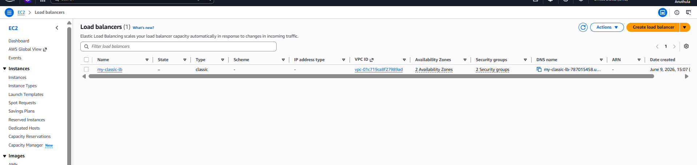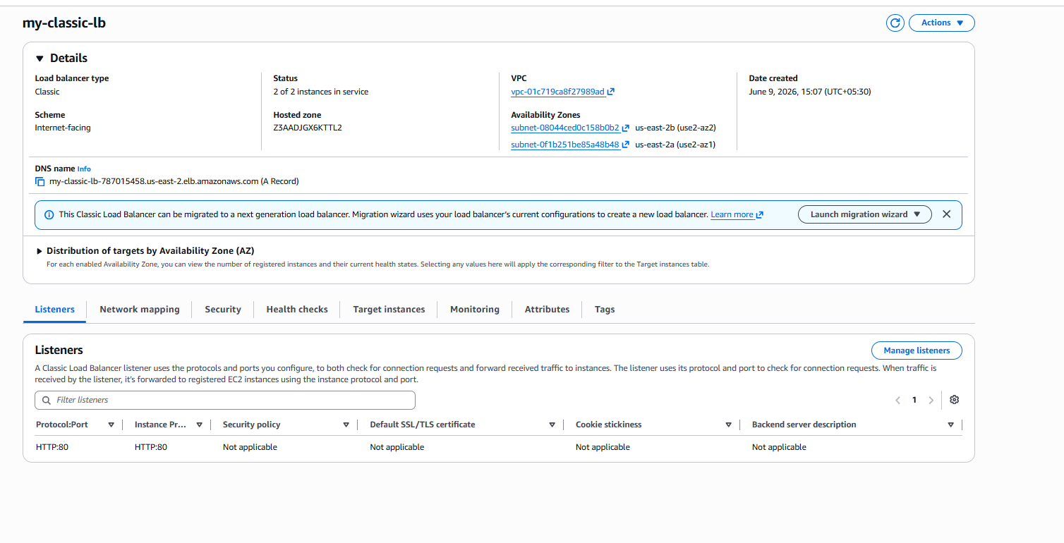my-classic-lb-787015458.us-east-2.elb.amazonaws.com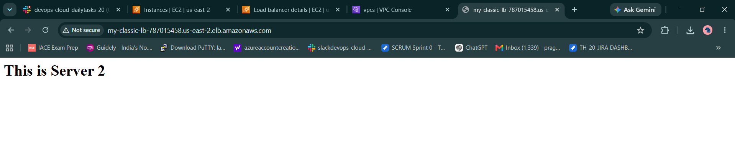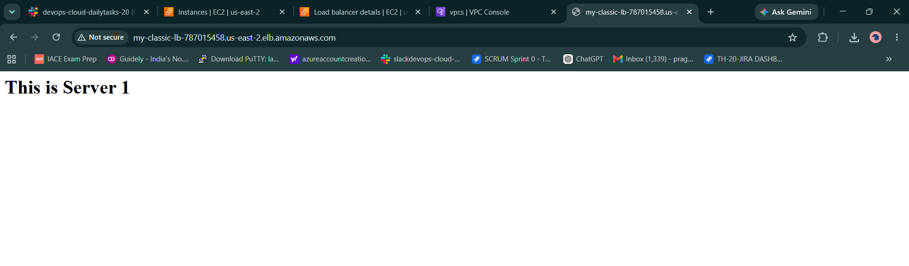

Task-2: Configure Application Load Balancer (ALB)
Objective
To configure an Application Load Balancer (ALB) and distribute incoming HTTP traffic across multiple EC2 instances deployed in different Availability Zones. The ALB provides high availability, fault tolerance, and Layer 7 (Application Layer) routing capabilities.

Architecture
User
|
|
Application Load Balancer
|
|
Target Group
|
---------------------
| |
| |
WebServer-1 WebServer-2
us-east-2a us-east-2b

Prerequisites
Before creating the ALB, the following resources were already available:
- Two EC2 instances
  - WebServer-1 (us-east-2a)
  - WebServer-2 (us-east-2b)
- Apache HTTP Server installed on both instances.
- Security Groups configured to allow:
  - SSH (Port 22)
  - HTTP (Port 80)
- Web application verified using public IP addresses.

Step 1: Create Target Group
Navigation
EC2 → Target Groups → Create Target Group
Configuration
Parameter | Value
Target Type | Instances
Protocol | HTTP
Port | 80
VPC | Existing VPC
Target Group Name | targetelb
Purpose
A Target Group acts as a logical collection of backend servers that receive traffic from the Application Load Balancer.

Step 2: Configure Health Checks
Health Check Configuration
Parameter | Value
Protocol | HTTP
Path | /
Port | Traffic Port
Purpose
Health checks continuously monitor the availability of backend EC2 instances.
If an instance becomes unhealthy:
ALB stops routing traffic
to that instance.
Only healthy instances receive user requests.

Step 3: Register Targets
Registered Instances
WebServer-1
WebServer-2
Port
80
Purpose
Registering targets allows the Application Load Balancer to forward incoming requests to these EC2 instances.

Step 4: Create Application Load Balancer
Navigation
EC2 → Load Balancers → Create Load Balancer
Load Balancer Type
Application Load Balancer

Step 5: Configure Basic Settings
Configuration
Parameter | Value
Name | my-alb
Scheme | Internet-facing
IP Address Type | IPv4
Purpose
An Internet-facing ALB receives traffic from internet users and distributes it to backend servers.

Step 6: Configure Network Mapping
Selected Availability Zones
us-east-2a
us-east-2b
Selected Subnets
- Subnet in us-east-2a
- Subnet in us-east-2b
Purpose
Deploying the ALB across multiple Availability Zones ensures high availability and fault tolerance.
If one Availability Zone fails, traffic continues to flow through healthy instances in the other Availability Zone.

Step 7: Configure Security Groups
Security Groups Selected
launch-wizard-2
launch-wizard-3
Allowed Traffic
Type | Port
HTTP | 80
Purpose
Security Groups allow incoming web traffic from users and permit communication between the ALB and backend EC2 instances.

Step 8: Configure Listener
Listener Configuration
Protocol | Port
HTTP | 80
Default Action
Forward to Target Group
Target Group:
targetelb
Purpose
The Listener receives incoming HTTP requests and forwards them to the configured Target Group.

Step 9: Create Load Balancer
After reviewing all settings, the Application Load Balancer was created successfully.
AWS automatically generated a DNS name.
Example:
my-alb-1118355062.us-east-2.elb.amazonaws.com

Step 10: Verify Target Health
Navigation
EC2 → Target Groups → targetelb → Targets
Result
Instance | Status
WebServer-1 | Healthy
WebServer-2 | Healthy
Verification
Healthy Targets = 2
Unhealthy Targets = 0
This confirms that both backend servers are available and ready to receive traffic.

Step 11: Test Application Load Balancer
Navigation
Open the ALB DNS name in a web browser.
http://my-alb-1118355062.us-east-2.elb.amazonaws.com
Output
This is Server 1
or
This is Server 2
Verification
Refreshing the page multiple times confirms that the ALB distributes traffic between the registered EC2 instances.

Result
Successfully configured an Application Load Balancer (ALB) in the Ohio Region and attached two EC2 web servers deployed in different Availability Zones. A Target Group was created, health checks were configured, and traffic was successfully routed through the ALB DNS endpoint. Both instances remained healthy, ensuring high availability, fault tolerance, and efficient traffic distribution.

Interview Answer
What is an Application Load Balancer?
An Application Load Balancer (ALB) is a Layer 7 load balancer that distributes HTTP and HTTPS traffic across multiple backend targets such as EC2 instances, containers, and IP addresses. It supports advanced routing features like path-based routing, host-based routing, and health checks, making it suitable for modern web applications and microservices architectures.
Why is ALB better than Classic Load Balancer?
Classic Load Balancer | Application Load Balancer
Layer 4 & Basic Layer 7 | Layer 7
Basic traffic distribution | Intelligent routing
No path-based routing | Supports path-based routing
No host-based routing | Supports host-based routing
Limited features | Advanced web application features
Real-Time Request Flow
User Request
|
|
V
Application Load Balancer
|
V
Target Group
|
---------------------
| |
V V
WebServer-1 WebServer-2
This architecture ensures scalability, availability, and efficient traffic management for web applications.
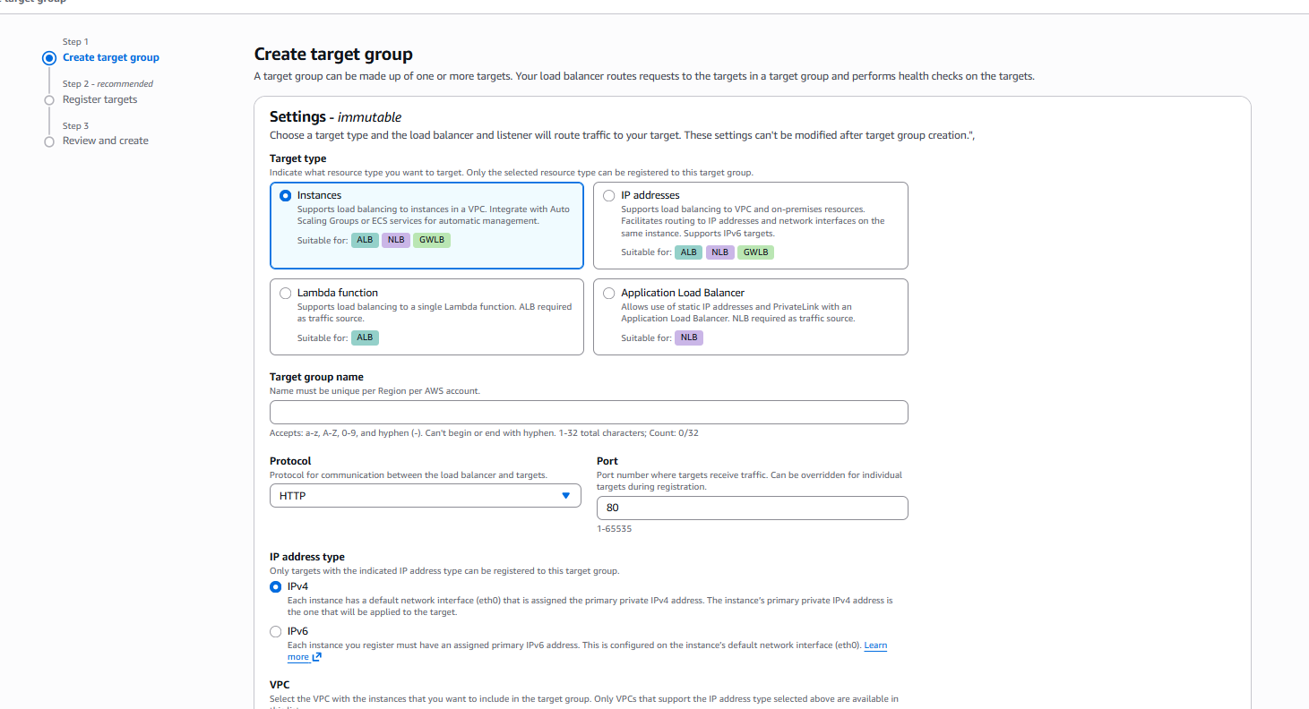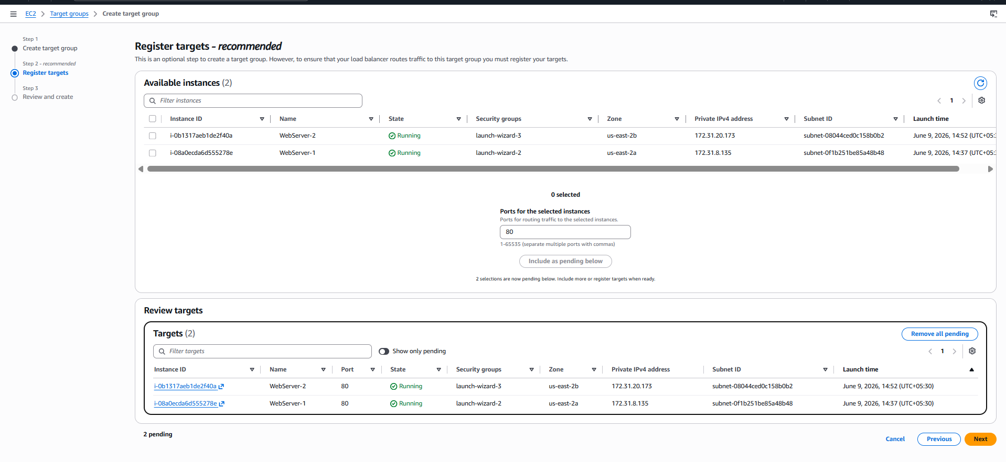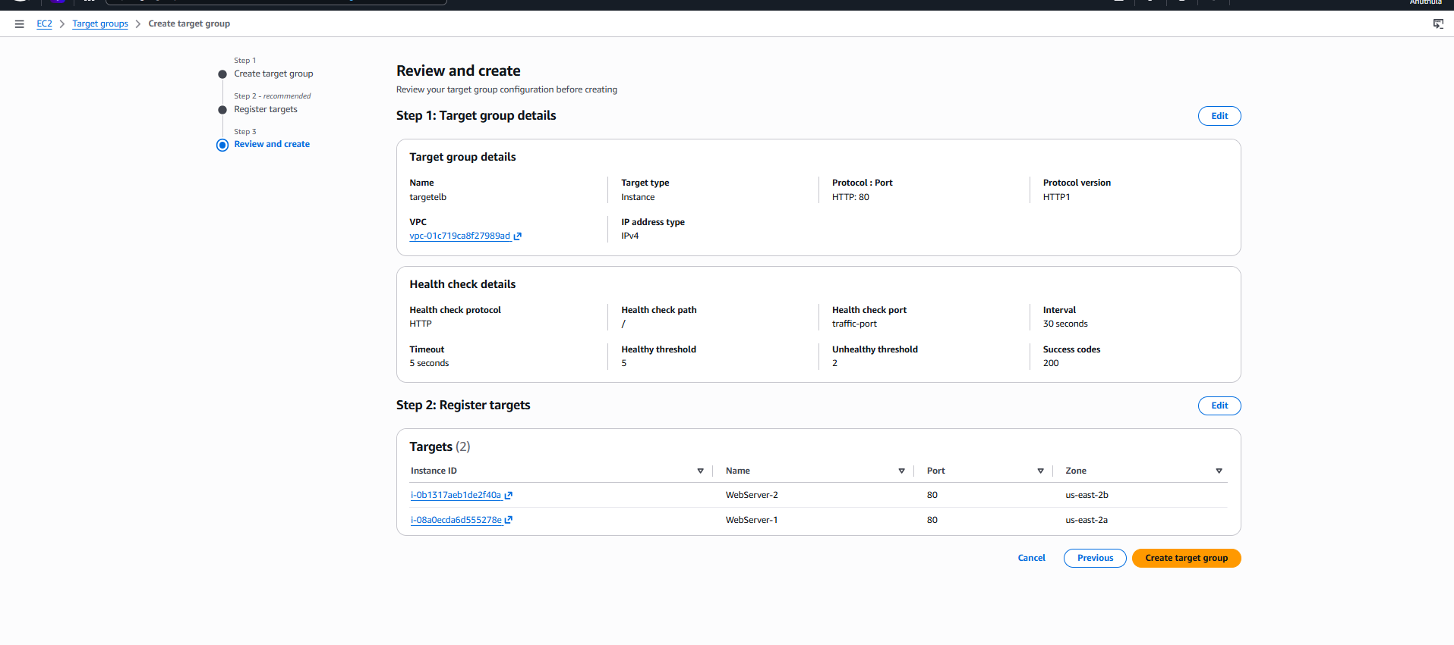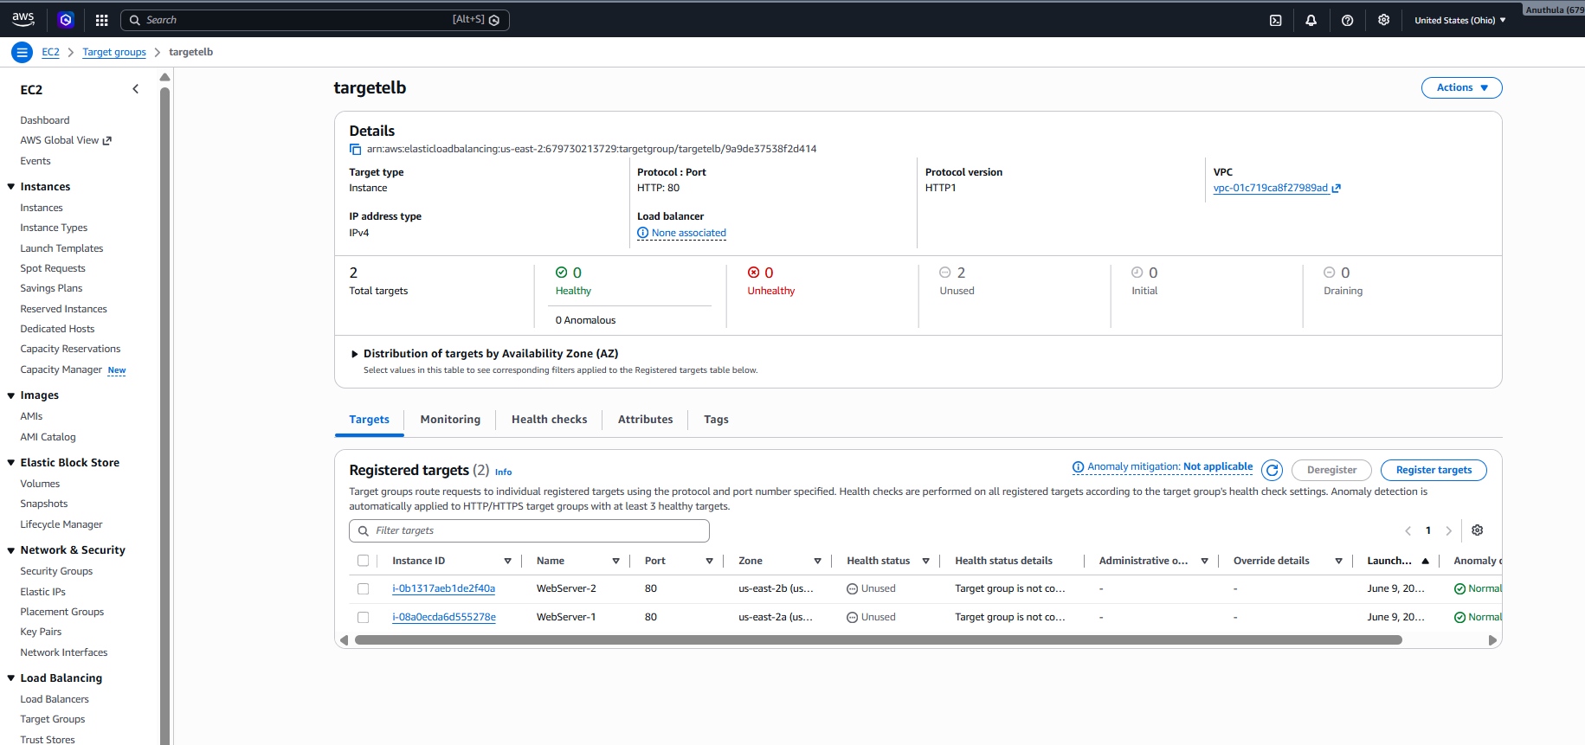
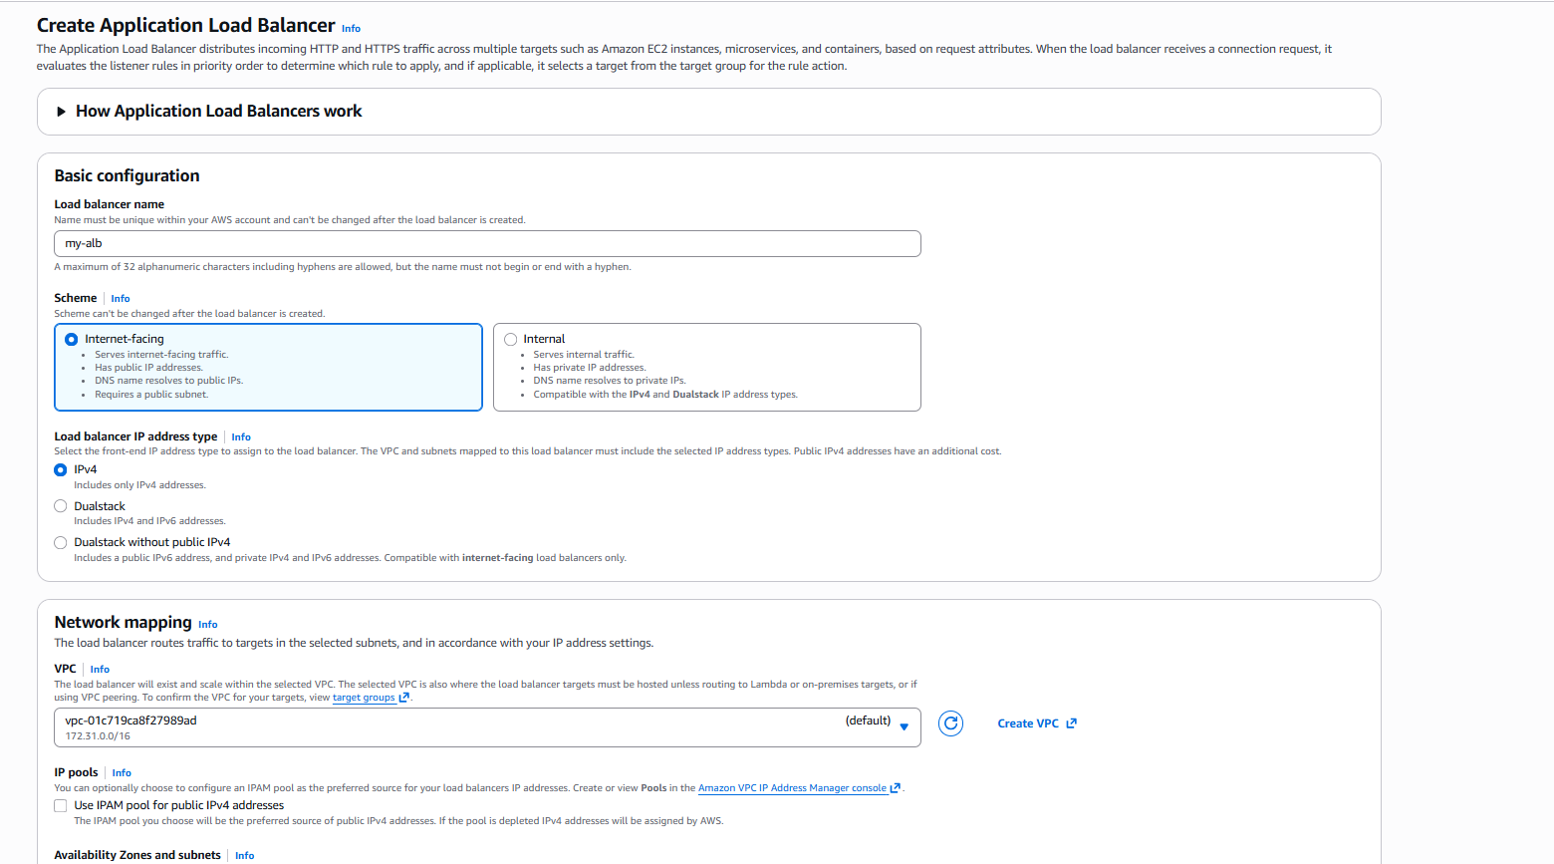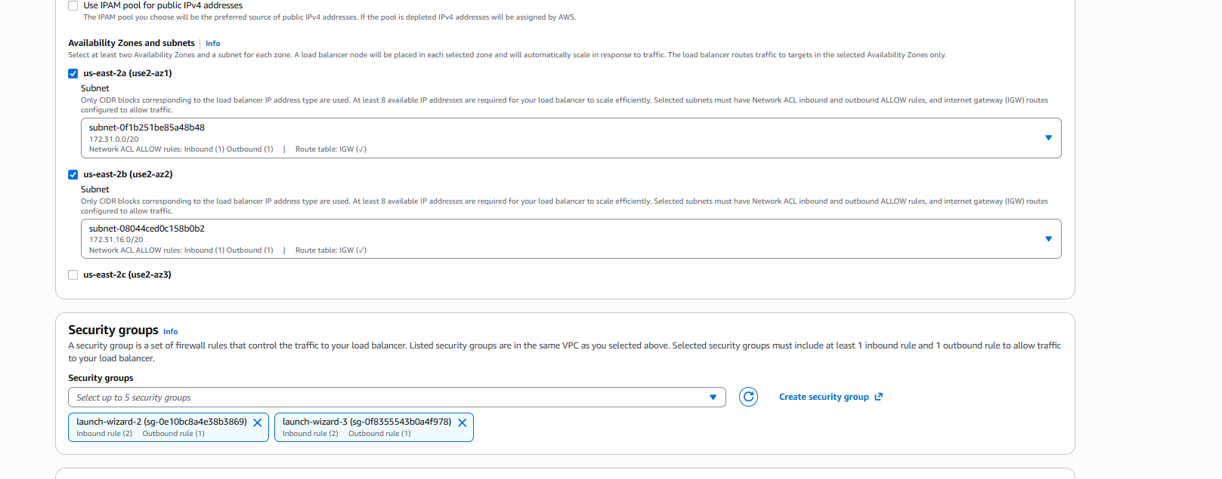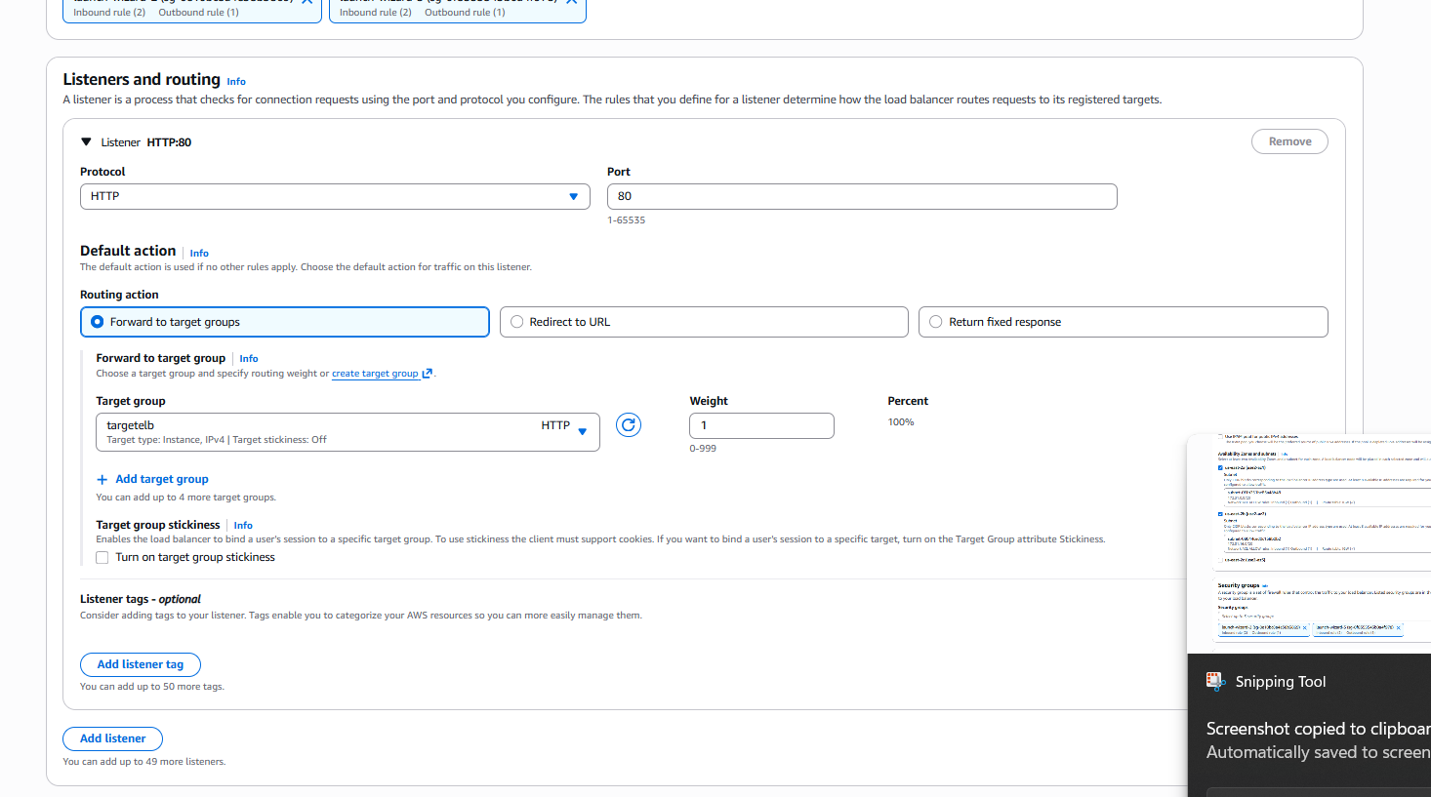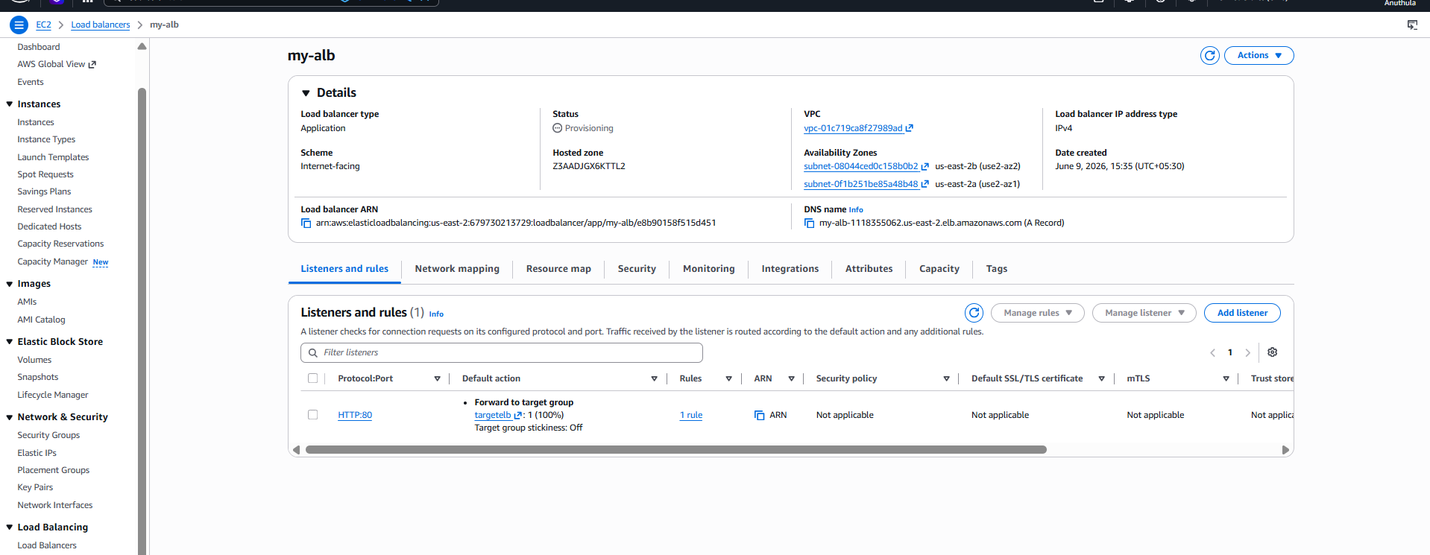my-alb-1118355062.us-east-2.elb.amazonaws.com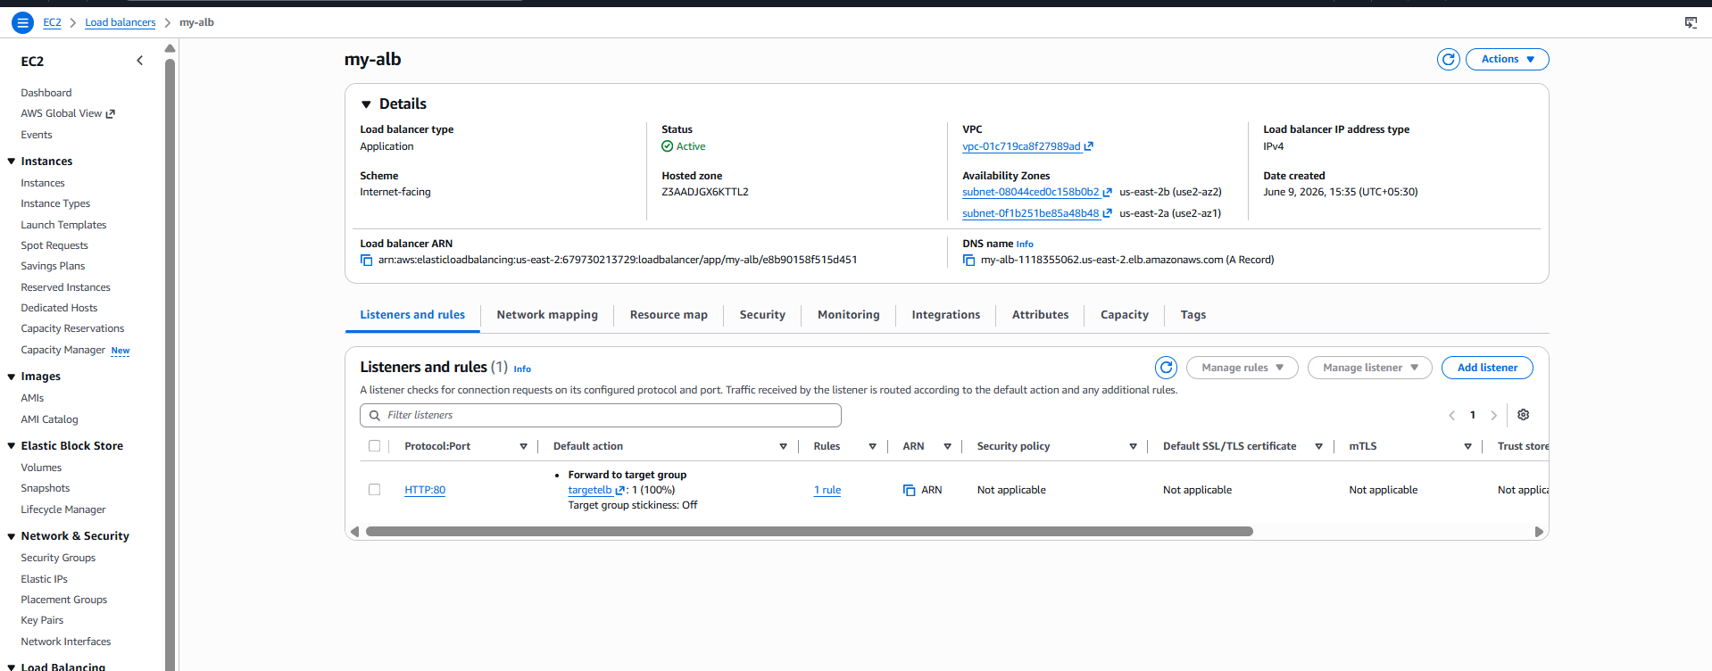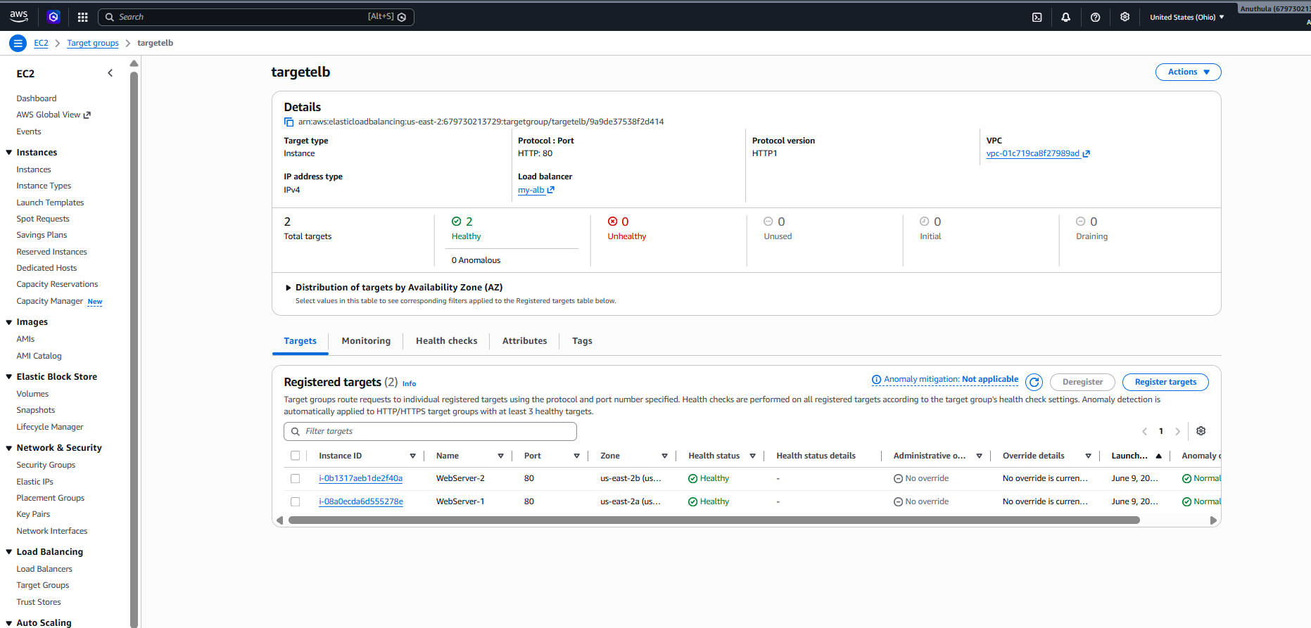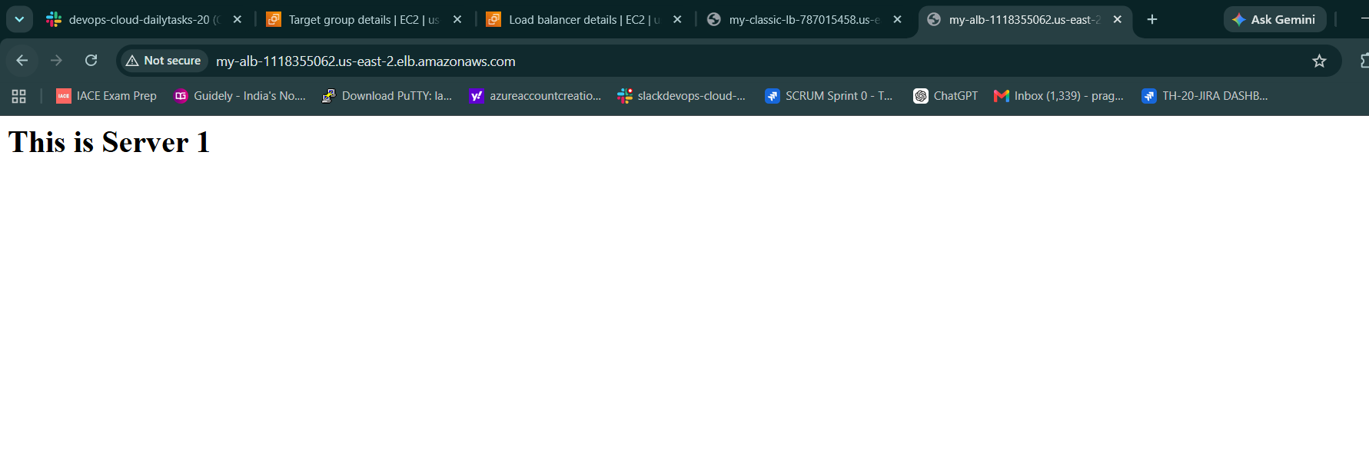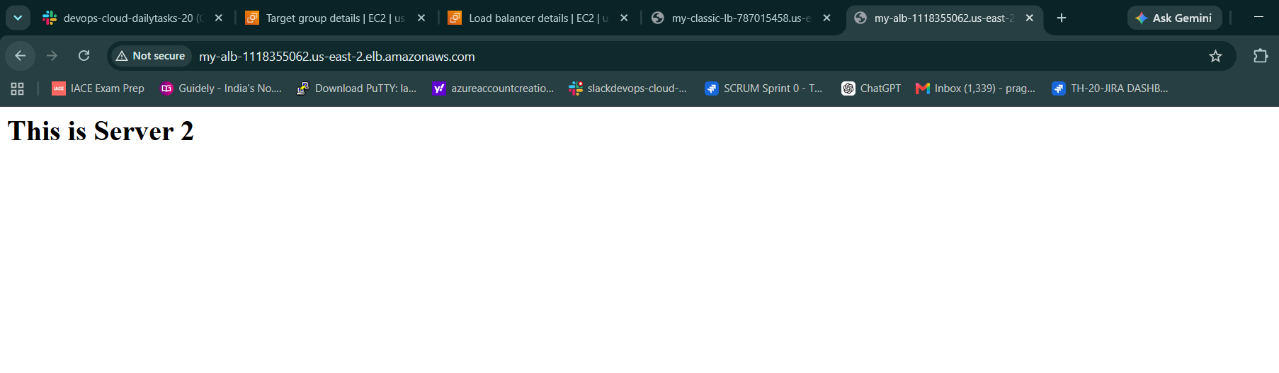

Task-3: Configure Network Load Balancer (NLB)
Objective
The objective of this task is to configure an AWS Network Load Balancer (NLB) to distribute incoming TCP traffic across multiple EC2 instances running Apache Web Server. The NLB ensures high availability, fault tolerance, and efficient traffic distribution across multiple Availability Zones.

Architecture
User
│
▼
Network Load Balancer (NLB)
│
├────────► WebServer-1 (us-east-2a)
│
└────────► WebServer-2 (us-east-2b)

Prerequisites
Before configuring the Network Load Balancer, the following resources were already available:
- AWS Account
- Ohio Region (us-east-2)
- VPC
- Two Public Subnets
- Two EC2 Instances
- Apache HTTP Server installed on both instances
- Security Groups allowing HTTP (Port 80)

Step 1: Launch EC2 Instances
Two EC2 instances were created in different Availability Zones.
Instance Name | Availability Zone
WebServer-1 | us-east-2a
WebServer-2 | us-east-2b
User Data Used
WebServer-1
#!/bin/bash
dnf update -y
dnf install httpd -y
systemctl start httpd
systemctl enable httpd
echo "<h1>This is Server 1</h1>" > /var/www/html/index.html
WebServer-2
#!/bin/bash
dnf update -y
dnf install httpd -y
systemctl start httpd
systemctl enable httpd
echo "<h1>This is Server 2</h1>" > /var/www/html/index.html

Step 2: Verify Apache Web Server
The public IP addresses of both EC2 instances were accessed through a web browser.
Expected Output
WebServer-1
This is Server 1
WebServer-2
This is Server 2
This confirmed that Apache was successfully installed and running on both instances.

Step 3: Create Target Group
Navigate to:
EC2
→ Target Groups
→ Create Target Group
Configuration
Parameter | Value
Target Type | Instances
Target Group Name | nlb-target-group
Protocol | TCP
Port | 80
IP Version | IPv4
VPC | Default VPC

Step 4: Configure Health Checks
Health checks were configured to monitor application availability.
Health Check Configuration
Parameter | Value
Protocol | HTTP
Path | /
This configuration allows AWS to verify whether Apache is responding successfully on each EC2 instance.

Step 5: Register Targets
The following EC2 instances were registered with the target group:
- WebServer-1
- WebServer-2
Port used:
80
After registration, the target group was created.

Step 6: Create Network Load Balancer
Navigate to:
EC2
→ Load Balancers
→ Create Load Balancer
→ Network Load Balancer

Step 7: Configure NLB
Basic Configuration
Parameter | Value
Load Balancer Name | network-lb
Scheme | Internet-facing
IP Address Type | IPv4

Step 8: Configure Network Mapping
Selected VPC:
Default VPC
Selected Availability Zones:
us-east-2a
us-east-2b
Selected Subnets:
Subnet for WebServer-1
Subnet for WebServer-2
This ensures the load balancer is deployed across multiple Availability Zones.

Step 9: Configure Security Groups
The following security groups were associated:
launch-wizard-2
launch-wizard-3
Inbound Rule:
HTTP (80) → Anywhere (0.0.0.0/0)

Step 10: Configure Listener
Listener Configuration
Parameter | Value
Protocol | TCP
Port | 80
Routing Configuration
Forward traffic to:
nlb-target-group

Step 11: Create Load Balancer
After reviewing all configurations:
Create Load Balancer
was selected.
AWS created the Network Load Balancer successfully.

Step 12: Verify Target Health
Navigate to:
EC2
→ Target Groups
→ nlb-target-group
→ Targets
Result
WebServer-1 → Healthy
WebServer-2 → Healthy
Healthy Targets:
2
Unhealthy Targets:
0
This confirmed that both EC2 instances were successfully registered and passing health checks.

Step 13: Test Network Load Balancer
Navigate to:
EC2
→ Load Balancers
→ network-lb
Copy the DNS name and open it in a browser.
Example Output
This is Server 1
or
This is Server 2
The Network Load Balancer successfully forwarded traffic to healthy backend EC2 instances.

Outcome
Successfully configured an AWS Network Load Balancer (NLB) that distributes incoming TCP traffic across two Apache web servers deployed in different Availability Zones. The implementation provides high availability, fault tolerance, and improved application reliability by ensuring traffic is routed only to healthy EC2 instances.
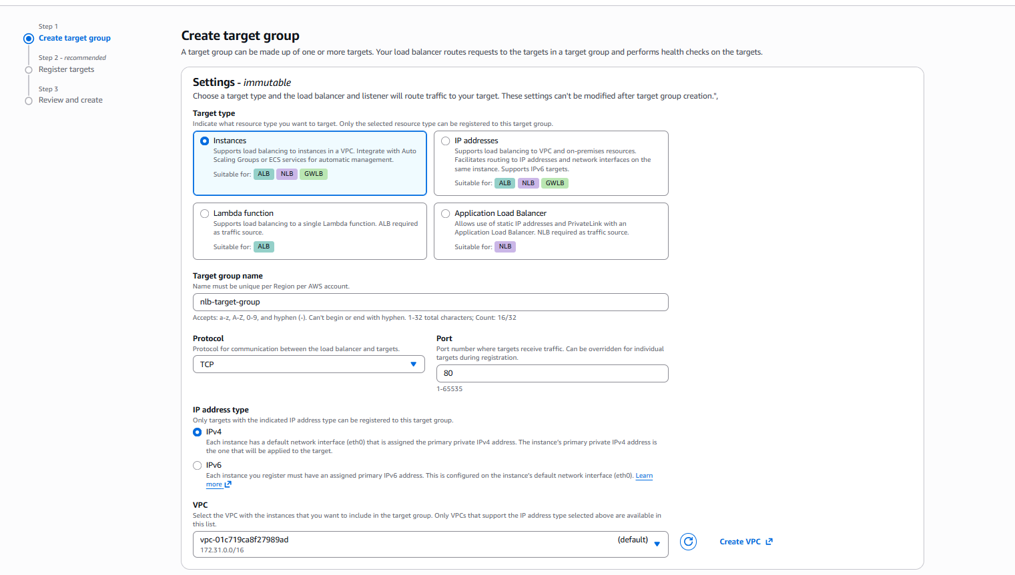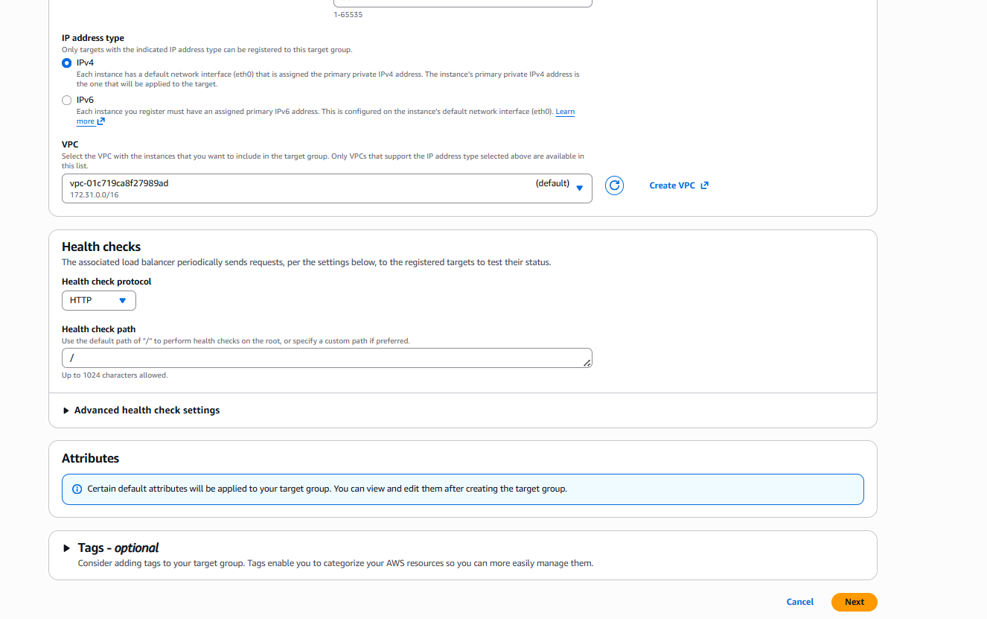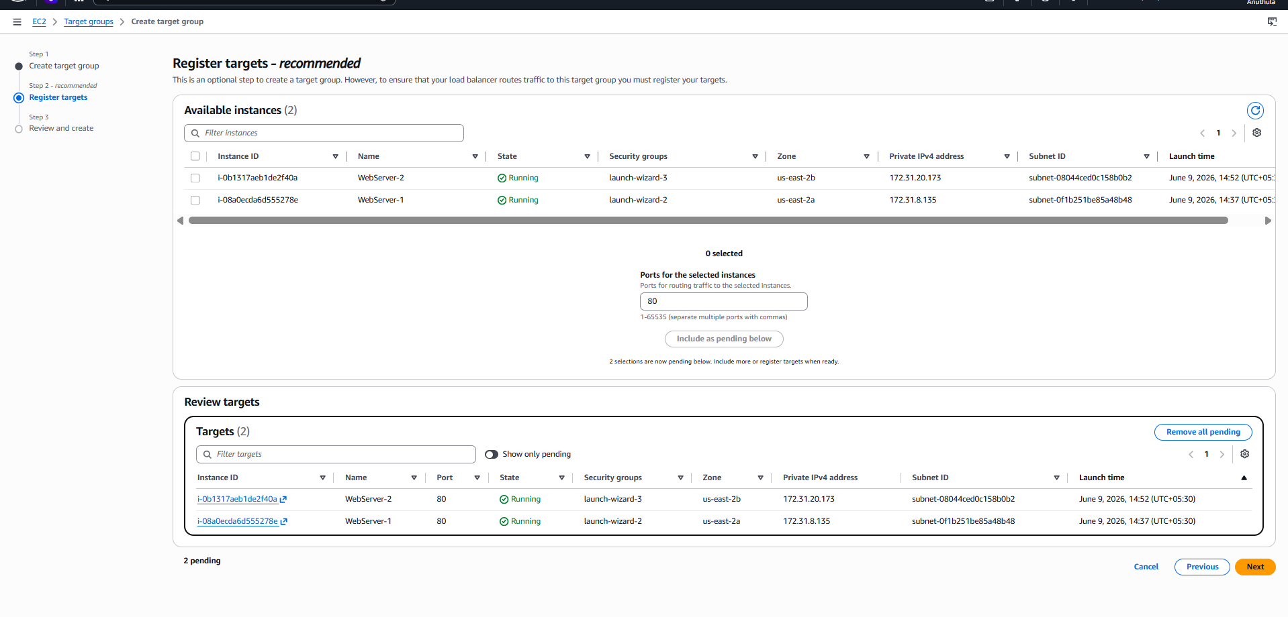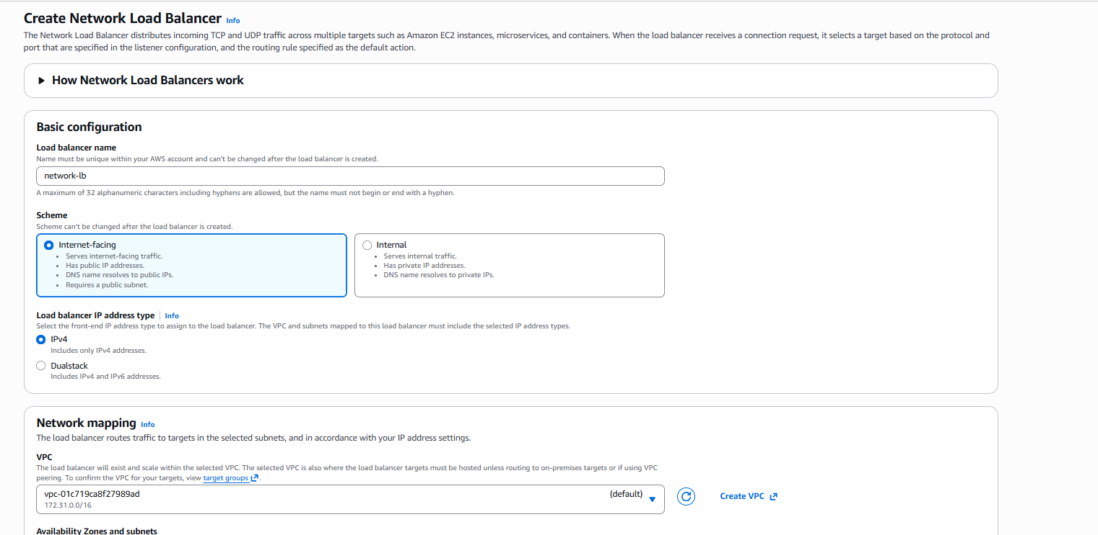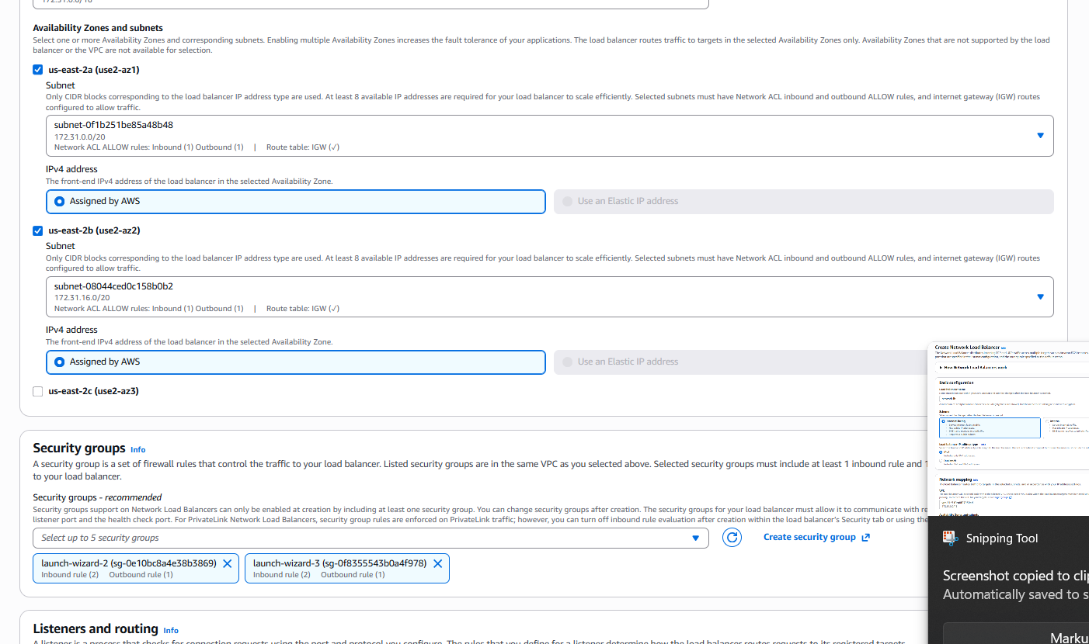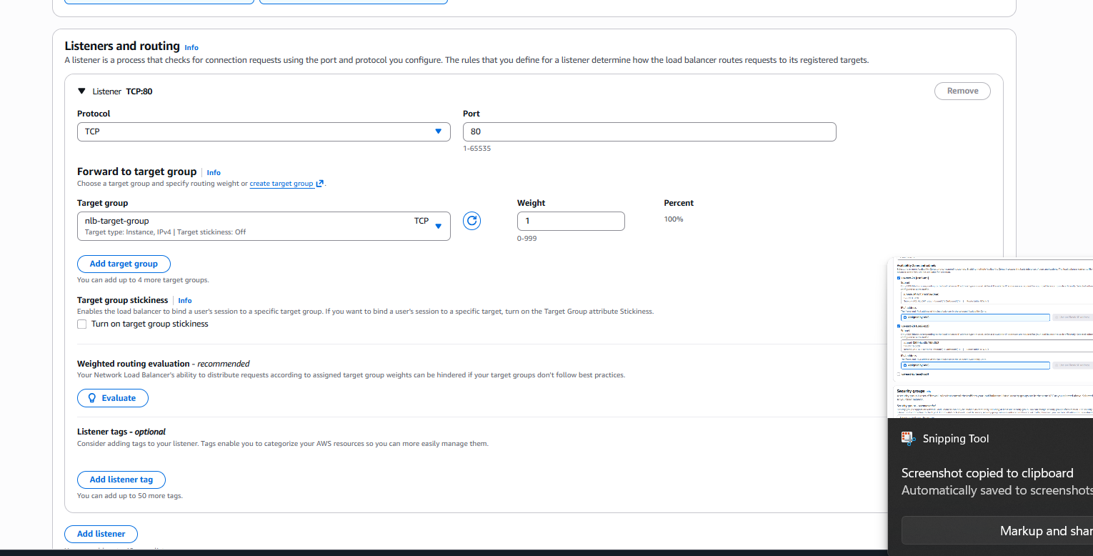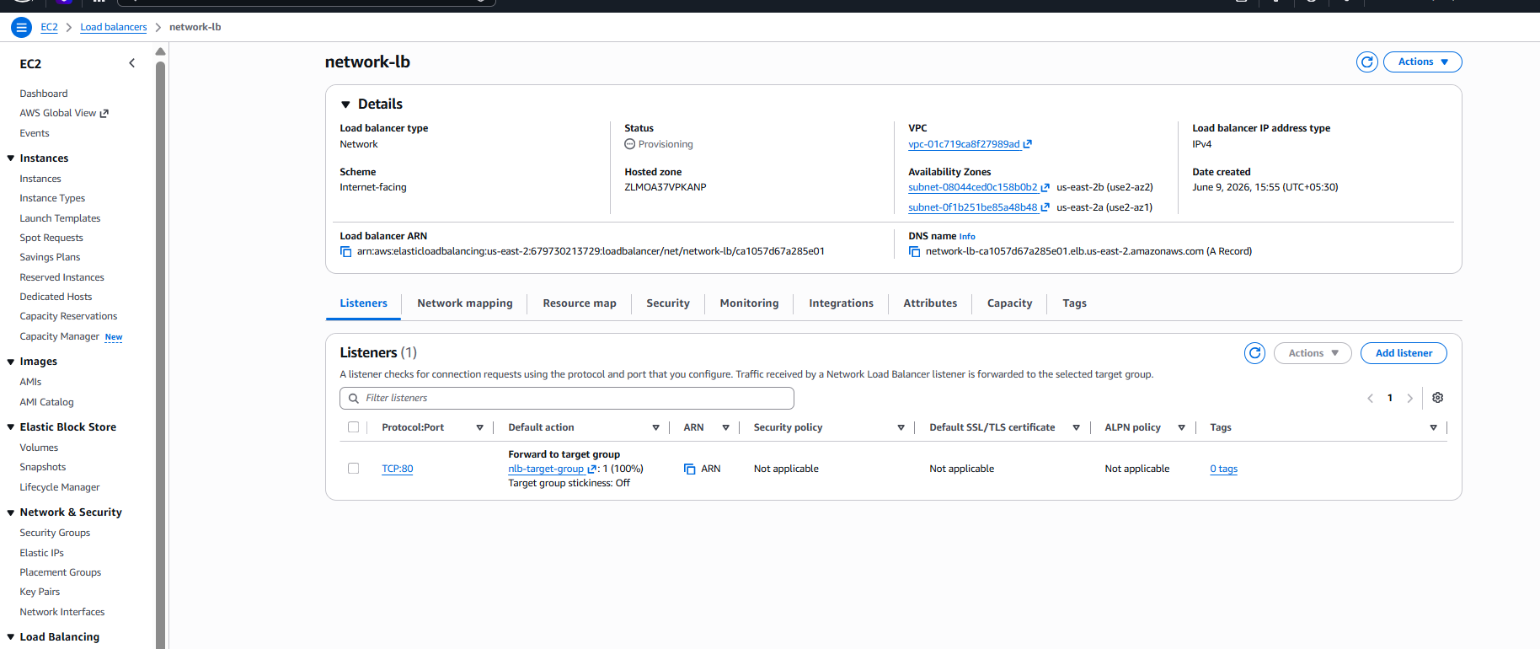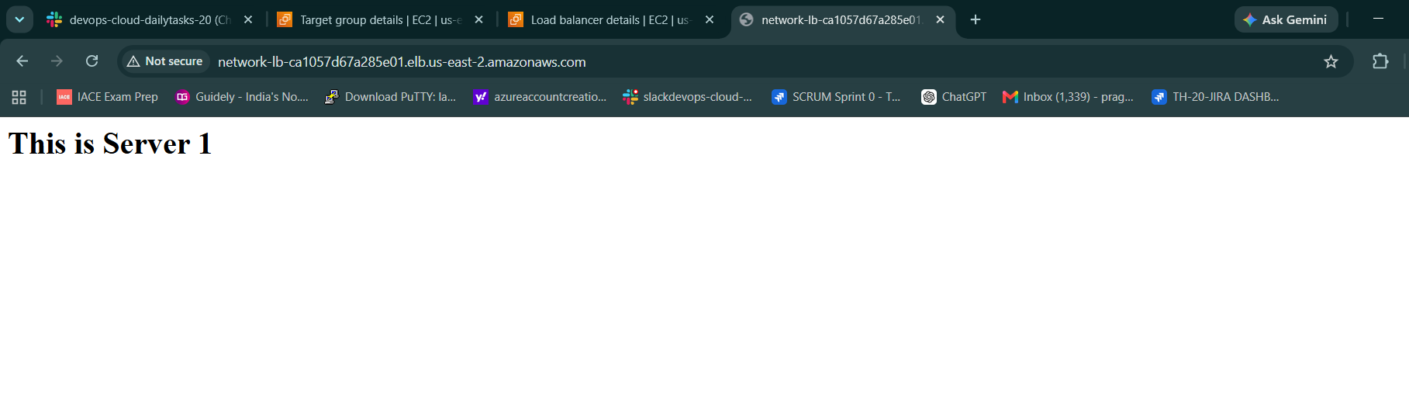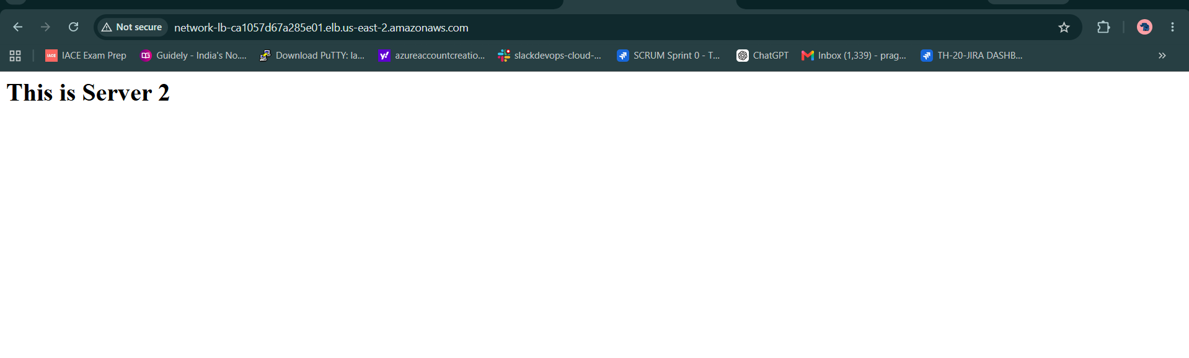
Task-4: Attach SSL Certificate to Application Load Balancer
Objective
The objective of this task is to secure the Application Load Balancer using an SSL/TLS certificate so that users can access the application securely through HTTPS instead of HTTP.

Architecture Before SSL
User
|
HTTP (Port 80)
|
Application Load Balancer
|
Target Group
|
EC2 Instances
Communication between users and the Load Balancer was not encrypted.

Architecture After SSL
User
|
HTTPS (Port 443)
|
SSL Certificate (ACM)
|
Application Load Balancer
|
Target Group
|
EC2 Instances
Communication between users and the Load Balancer is encrypted using SSL/TLS.

Prerequisites
Before attaching SSL, the following resources were already available:
- Domain Name: sashadevopsdemo.shop
- Route 53 Hosted Zone
- Application Load Balancer (ALB)
- Target Group
- EC2 Instances running Apache Web Server
- Domain mapped to ALB

Step 1: Request SSL Certificate from ACM
- Navigate to AWS Certificate Manager (ACM).
- Click Request Certificate.
- Select Request a Public Certificate.
- Click Next.
Domain Names Added
sashadevopsdemo.shop
www.sashadevopsdemo.shop
Validation Method
Selected:
DNS Validation
Key Algorithm
Selected:
RSA 2048
- Click Request.

Step 2: Validate Domain Ownership
- ACM generated CNAME validation records.
- Since Route 53 Hosted Zone already existed, validation records were created automatically.
- ACM verified domain ownership.
Certificate status changed from:
Pending Validation
to
Issued

Step 3: Add HTTPS Listener to ALB
- Open EC2 Console.
- Navigate to:
Load Balancers
- Select:
my-alb
- Click:
Add Listener
Listener Configuration
Setting | Value
Protocol | HTTPS
Port | 443

Step 4: Configure Routing
Under Routing Action:
Selected:
Forward to Target Group
Target Group:
targetelb
This ensures HTTPS traffic is forwarded to the backend EC2 servers.

Step 5: Attach SSL Certificate
Under Secure Listener Settings:
Certificate Source
Selected:
From ACM
Certificate
Selected:
sashadevopsdemo.shop
Security Policy
Used AWS Recommended Policy:
ELBSecurityPolicy-TLS13-1-2
This policy supports modern TLS encryption standards.

Step 6: Create HTTPS Listener
- Review configuration.
- Click:
Add Listener
AWS created:
HTTPS Listener : 443
and attached the ACM SSL certificate.

Step 7: Configure HTTP to HTTPS Redirect
To ensure all users use secure connections:
- Edit HTTP Listener (Port 80).
- Change Default Action.
Selected:
Redirect to URL
Redirect Settings
Setting | Value
Protocol | HTTPS
Status Code | 301 Permanent Redirect
- Save Changes.
Now all HTTP requests automatically redirect to HTTPS.

Step 8: Verify SSL Configuration
Open Browser:
https://sashadevopsdemo.shop
Verification Results:
SSL Status
Connection is Secure
Certificate Status
Issued
HTTPS Status
Working Successfully
Domain Access
Accessible through HTTPS

Verification
Test 1
Access:
http://sashadevopsdemo.shop
Result:
Automatically redirected to HTTPS

Test 2
Access:
https://sashadevopsdemo.shop
Result:
Website loaded successfully

Test 3
Click Browser Lock Icon
Result:
Connection is Secure
SSL certificate successfully verified.

Outcome
Successfully configured SSL/TLS encryption for the Application Load Balancer using AWS Certificate Manager (ACM). HTTPS listener was created on port 443, the SSL certificate was attached to the ALB, and HTTP traffic was redirected to HTTPS, ensuring secure communication between users and the application.
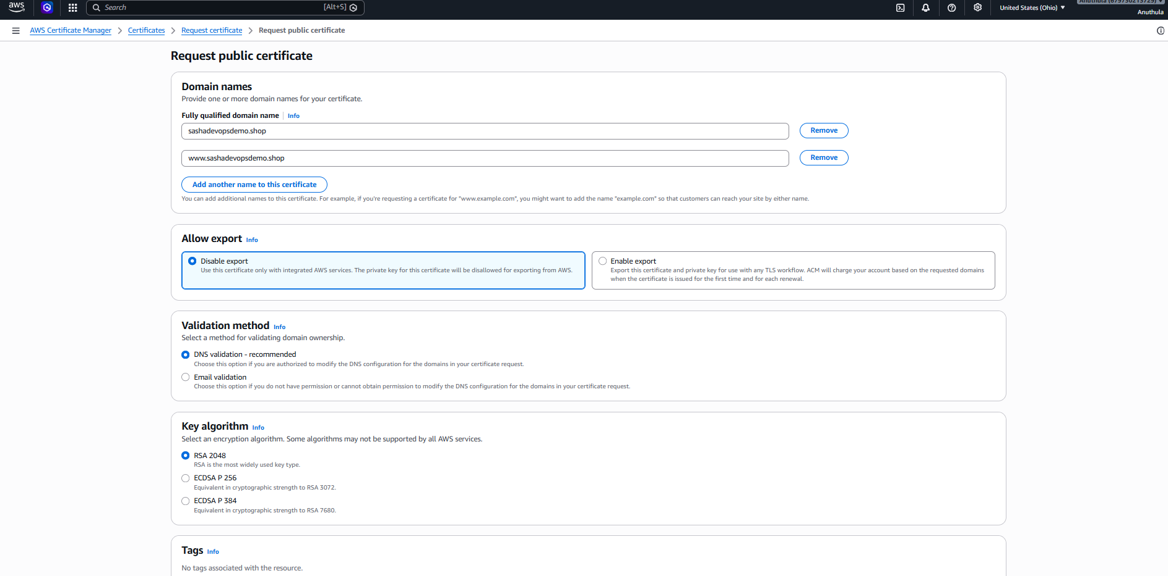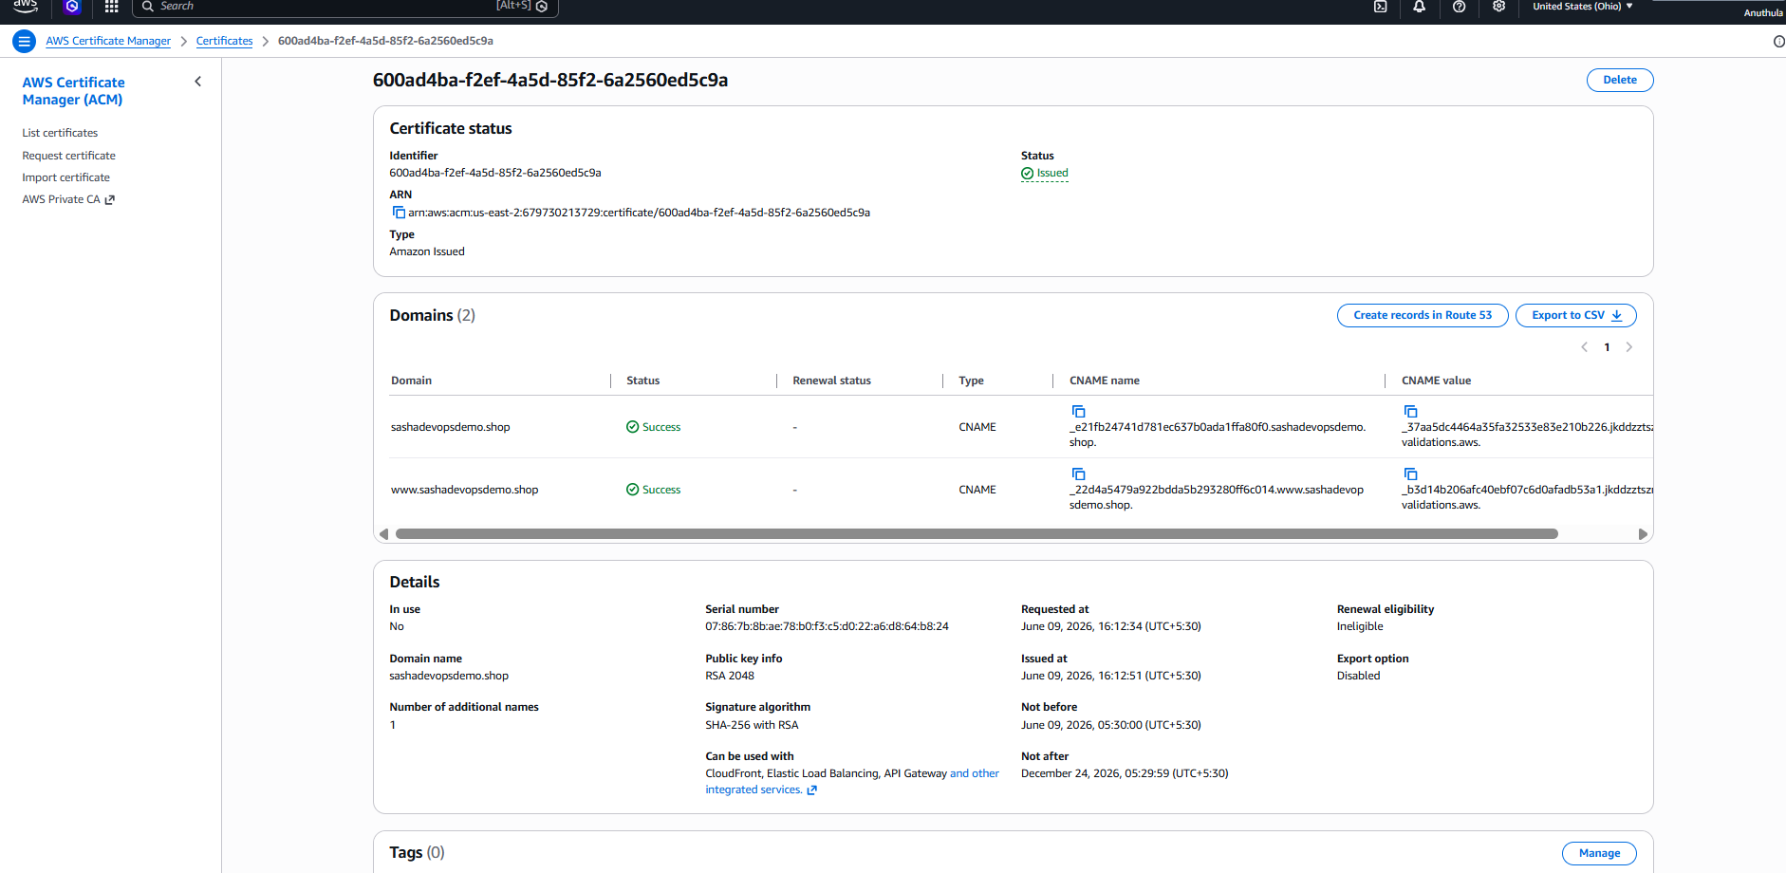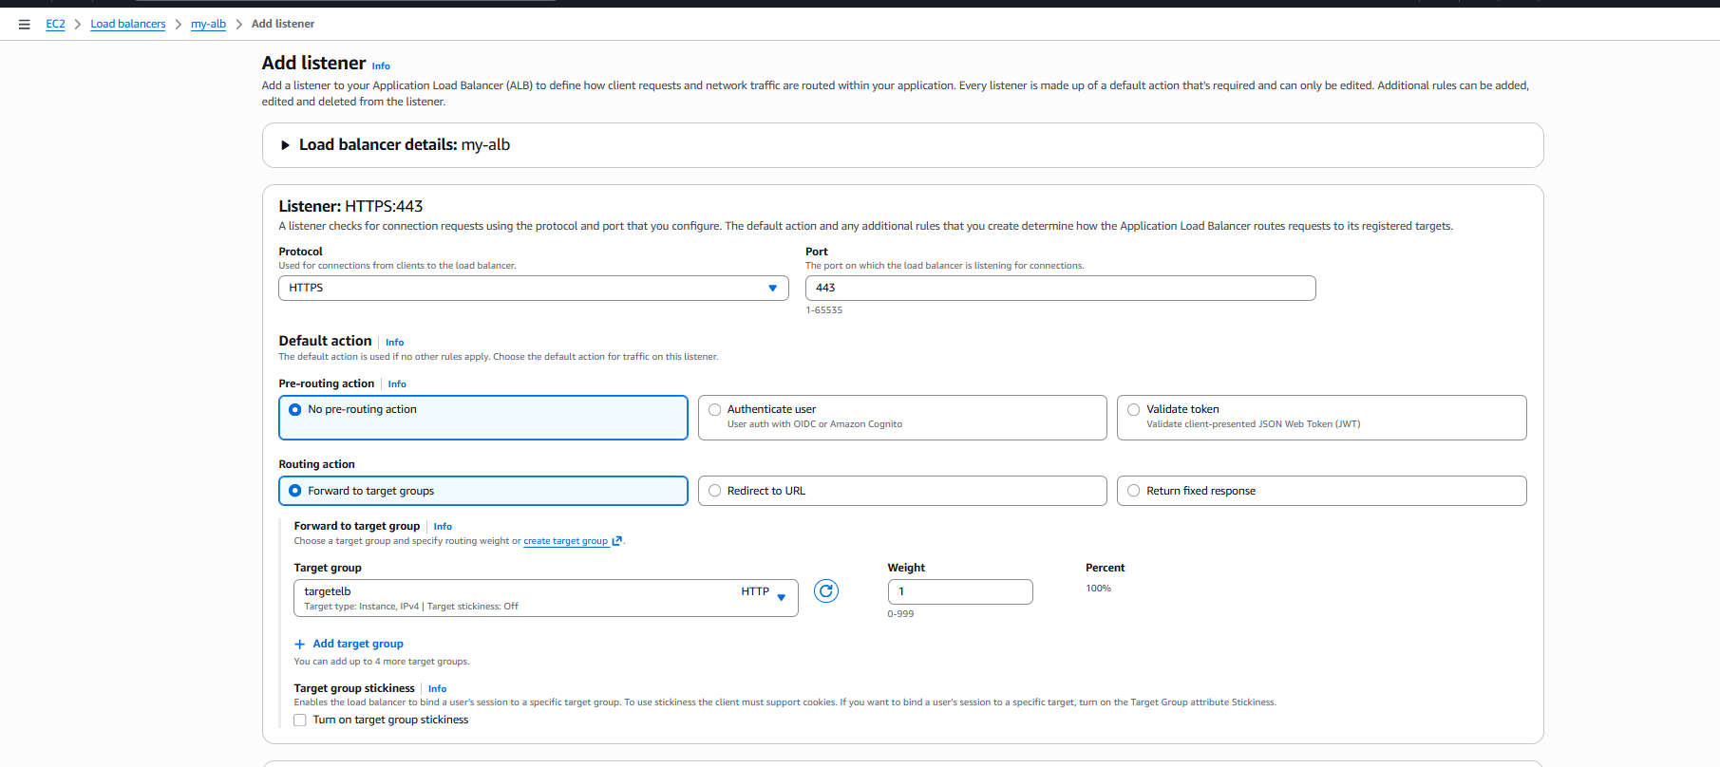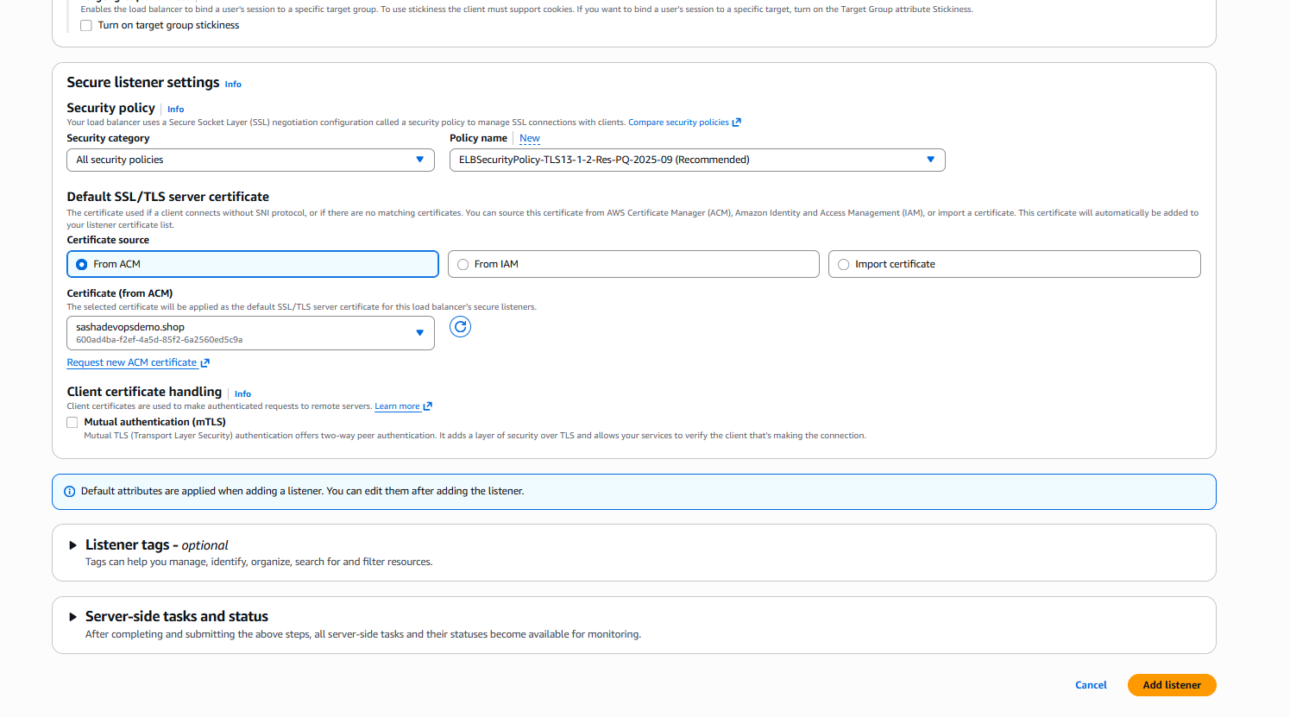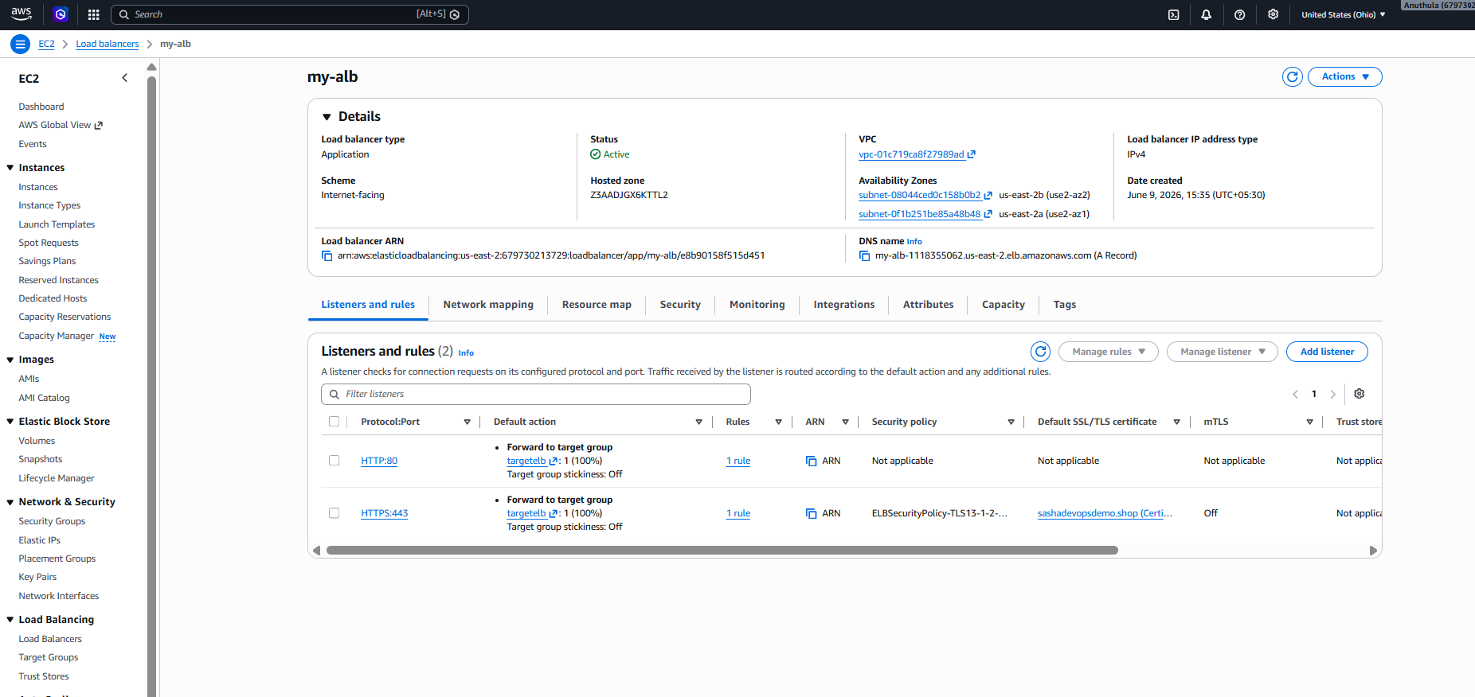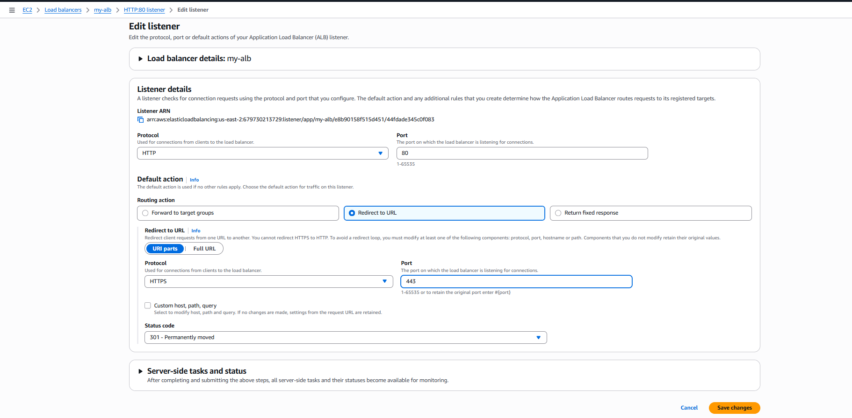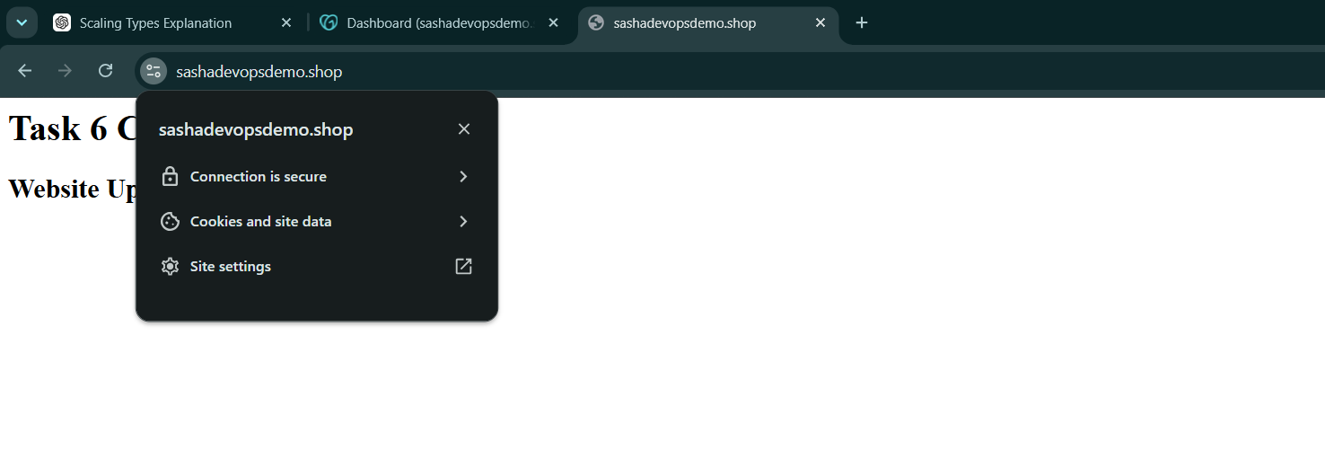

Task-5: Map Application Load Balancer to Route 53
Objective
To connect the custom domain:
sashadevopsdemo.shop
with the Application Load Balancer so users can access the website using the domain name instead of the ALB DNS name.

Architecture
User
↓
sashadevopsdemo.shop
↓
Route 53
↓
Application Load Balancer
↓
Target Group
↓
WebServer-1 / WebServer-2

Step 1: Verified Application Load Balancer
First, the Application Load Balancer was already created and active.
ALB name:
my-alb
ALB DNS:
my-alb-1118355062.us-east-2.elb.amazonaws.com
The ALB was forwarding traffic to the target group:
targetelb

Step 2: Opened Route 53 Hosted Zone
Navigated to:
Route 53
→ Hosted Zones
→ sashadevopsdemo.shop
The hosted zone for the domain was available in Route 53.

Step 3: Updated A Record
Selected the existing root domain record:
sashadevopsdemo.shop
Record type:
A
Alias:
Enabled
The record was updated to point to:
Alias to Application and Classic Load Balancer
Region selected:
US East (Ohio)
Load Balancer selected:
my-alb

Step 4: Saved the Record
After updating the Route 53 record, clicked:
Save
Route 53 showed:
sashadevopsdemo.shop was successfully updated

Step 5: Verified Route 53 Record
The A record was confirmed to point to:
dualstack.my-alb-1118355062.us-east-2.elb.amazonaws.com
This confirms that the domain is mapped to the Application Load Balancer.

Step 6: Tested Domain Access
Opened the domain in browser:
https://sashadevopsdemo.shop
The website loaded successfully.
Browser showed:
Connection is secure

Result
Successfully mapped the custom domain to the Application Load Balancer using Route 53 Alias A record.
Now users can access the application securely using:
https://sashadevopsdemo.shop

Final Outcome
Route 53 Domain
↓
Application Load Balancer
↓
Target Group
↓
EC2 Web Servers
The domain is successfully resolving to the ALB and serving the website through HTTPS.

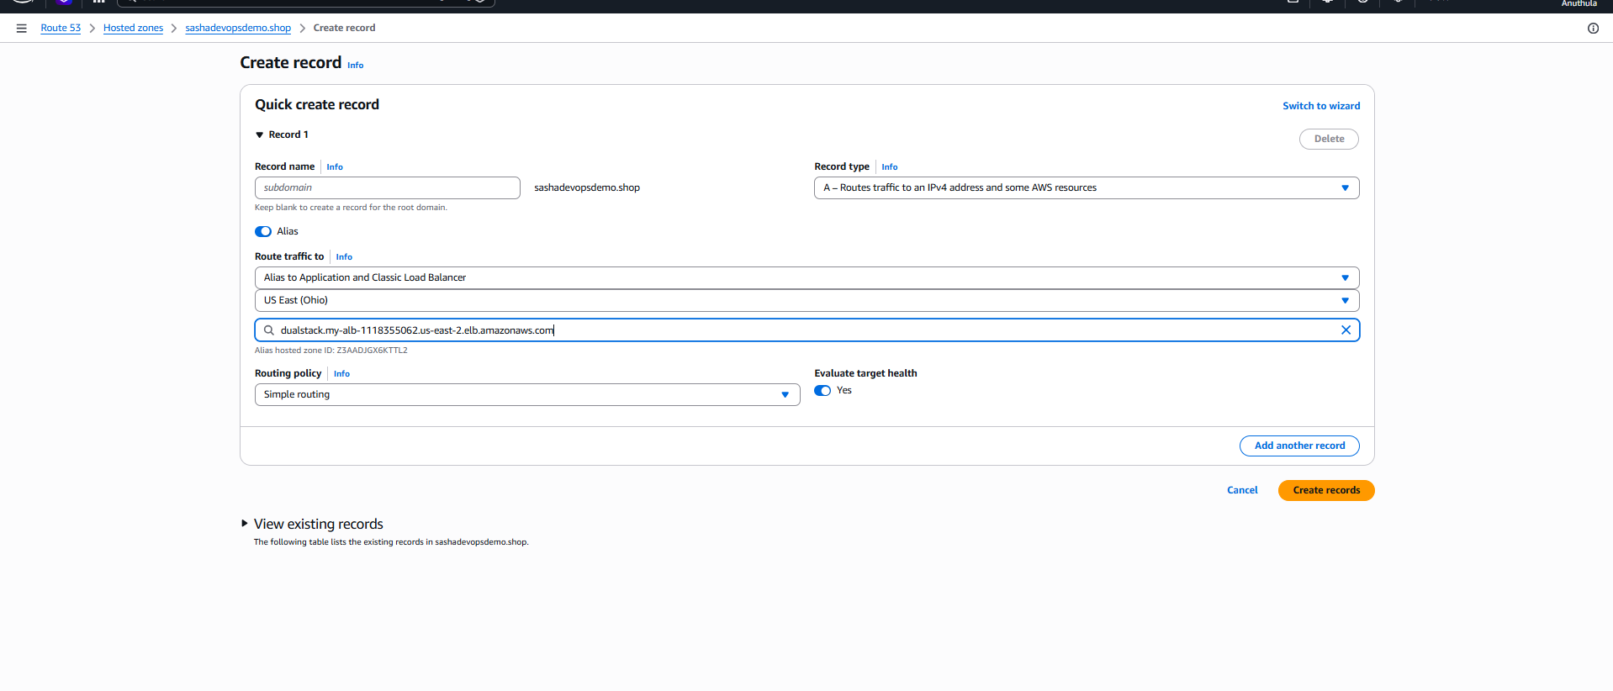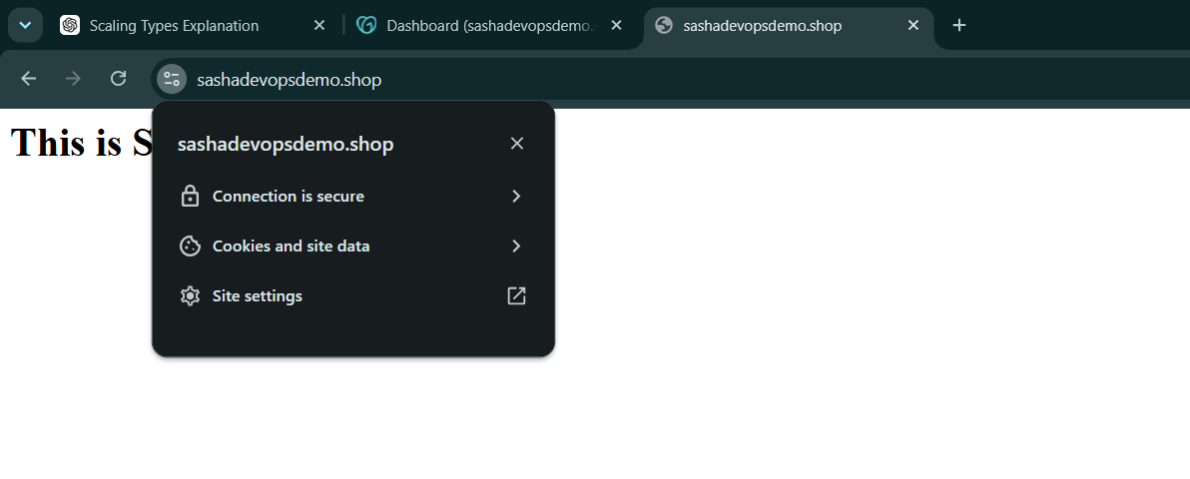

Task-6: Push Application Load Balancer Logs to S3
Objective
To enable Access Logs for the Application Load Balancer and store those logs in an S3 bucket for monitoring, troubleshooting, auditing, and traffic analysis.

Architecture
User
↓
sashadevopsdemo.shop
↓
Application Load Balancer
↓
Access Logs
↓
Amazon S3 Bucket

Step 1: Created S3 Bucket
Created an S3 bucket to store ALB logs.
Bucket Name: sasha-alb-access-logs
Region: US East (Ohio)
Purpose:
This bucket stores the access logs generated by the Application Load Balancer.

Step 2: Opened Application Load Balancer
Navigated to:
EC2
→ Load Balancers
→ my-alb
→ Attributes
In the Attributes section, logging was initially:
Access Logs: Off

Step 3: Enabled Access Logs
Clicked:
Edit
Then under Logging section:
Access Logs: Enabled
S3 URI configured as:
s3://sasha-alb-access-logs

Step 4: Saved ALB Logging Configuration
Clicked:
Save changes
This allowed the Application Load Balancer to start sending access logs to the selected S3 bucket.

Step 5: Generated Traffic
Opened the application domain:
https://sashadevopsdemo.shop
Refreshed the page multiple times.
Example output:
This is Server 2
Purpose:
Traffic was generated so the ALB could create access log entries.

Step 6: Verified S3 Log Folder
Opened the S3 bucket:
S3
→ sasha-alb-access-logs
AWS automatically created the folder structure:
AWSLogs/
└── 679730213729/
└── elasticloadbalancing/
└── us-east-2/
└── 2026/
└── 06/
└── 09/

Step 7: Verified Log Files
Inside the final date folder, log files were generated.
Example log files:
679730213729_elasticloadbalancing_us-east-2_app.my-alb...
File format:
.log.gz
This confirms that ALB access logs are successfully delivered to S3.

Result
Application Load Balancer access logging was successfully enabled and logs were pushed to Amazon S3.
Access Logs: Enabled
S3 Bucket: sasha-alb-access-logs
Log Files: Generated Successfully

Outcome
The ALB is now storing traffic logs in S3. These logs can be used for:
Monitoring
Troubleshooting
Security auditing
Traffic analysis
Compliance tracking
Task-6 completed successfully.
